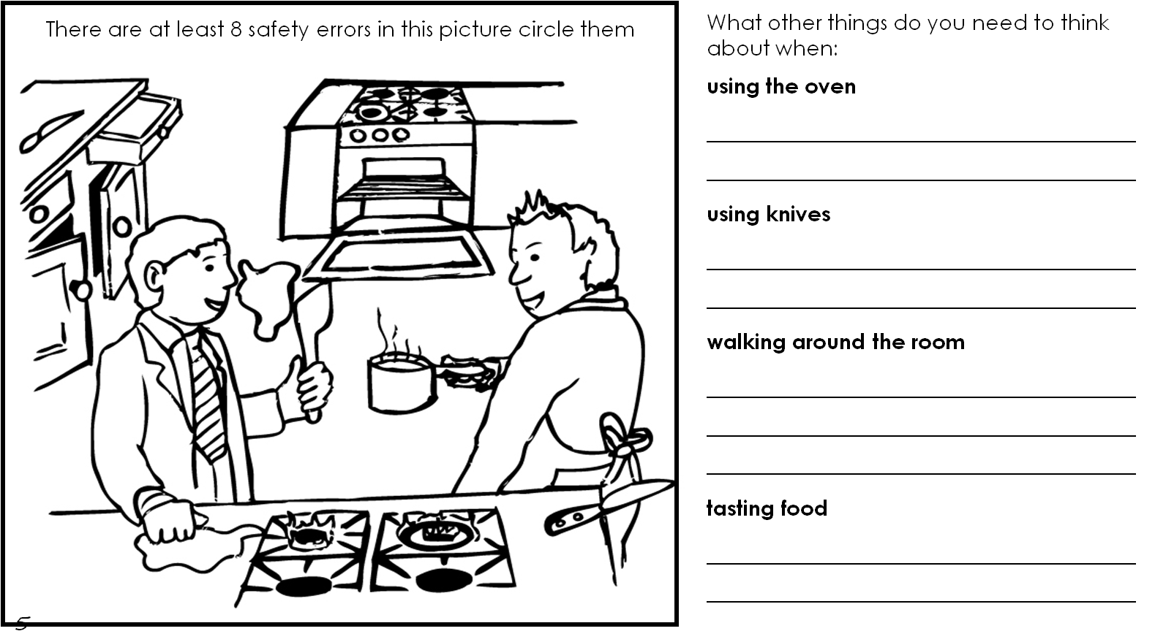

Name: _______________________________________ Group: ____________

**Safety**