Year 7 School Closure Work

Please log on to
www.languagesonline.org.uk

Click on ‘le français’ and pick the unit of work that you need to revise, recall or revisit in relation to your next steps or your classwork
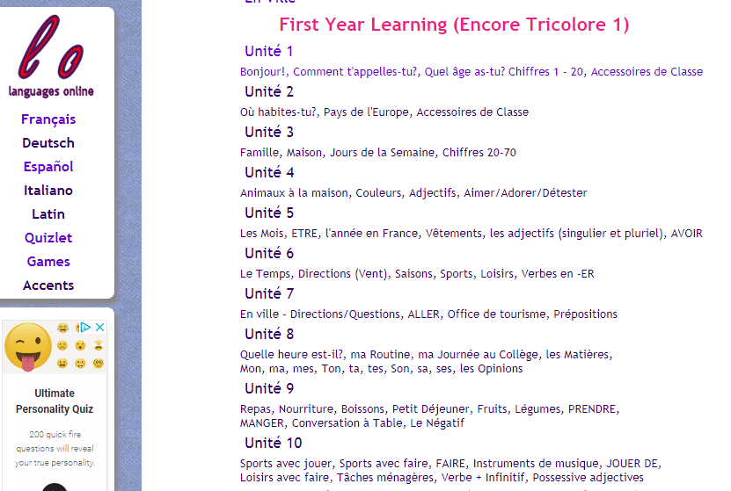

You also have numerous grammar activities you could work through and even go back to basics and complete :

Following this website you can log on to www.quizlet.com and enhance your learning by creating your own vocab/ memory game.

If you do not have access to the internet then I would like you to create a collage of all the language you have learnt in French since September.

Merci!!

