Work-related Learning/Careers/IAG
PSE Department

Name: | Date Started: | Date Passed:
Teacher: | Group: | Deadline for Completion:

Work-related Learning/Careers/IAG
This unit will cover:

- Identification of personal strengths, interests, skills and qualities
- Different types of employment
- Employment sectors
- Laws relating to young people’s permitted hours/types of work
- Basic banking: Budgeting, savings and debt

Lesson objectives are stated at the top of each page. Pupils should insert the date and complete tasks in the space provided. Any additional sheets can be stapled to the back of the booklet.

Self-Assessment boxes should be completed at the end of each section
Assessment ‘Traffic Light’ sheet should be completed at the end of the unit.

- Be able to identify personal strengths, interests, skills and qualities and relate them to opportunities for employment

Strengths | Interests
Skills | Qualities

Which jobs may be suitable for someone with your attributes?
Jobs  1.  2.  3.  4. | Reason(s)  1.  2.  3.  4.

- Understand that there are different types of employment
Part-time permanent full-time temporary voluntary zero-hours contract supply shift-work casual flexi-time Self-employed

Work with a partner to match the definition to the type of work
- I am a leaflet distributor. I only work when I am needed. _________
- I am a nurse. I work long hours over a few days and then have some time off. ____________
- I am a retired teacher and I work in lots of different schools when they are short of staff _____________
- I am a shop assistant and work shorter hours to suit my other commitments ______________
- I am a charity worker and I do not get a wage for the work that I do ______________
- I work from 9am – 5pm in an office as an administration assistant. I have a contract for 6 months __________
- I am a civil servant a permanent contract and can adjust my hours to suit my needs so long as I work for 37 hours each week _______________________
- I am a gas engineer and my job is permanent. I will stay with British Gas until I retire ______________
- I am a carer and am employed by a care home. I am needed to work different hours each week. I may have weeks where I am not needed but I am still technically ‘employed’._______________________
- I am a dentist. I work 40 hours per week. I have 6 weeks paid holiday per year._____________
- I am a roofer and I have my own roofing business. I pay my own wages and run my own vehicle. I also arrange to pay my own tax, pension and National Insurance ___________________________
- Be able to match particular jobs with their ‘sector’.
Use each picture as the centre for a spider diagram.
How many different jobs are needed to build a house?

plumber

How many different jobs are needed to run a large secondary school?

Catering assistant

SECTOR | JOBS | Salary (Guess) | Salary (Actual)
Business/Finance | 1.
 | 2.
Hospitality/Catering | 1.
 | 2.
Construction | 1.
 | 2.
Creative/Media | 1.
 | 2.
Information Technology | 1.
 | 2.
Leisure/ Sport | 1.
 | 2.
Retail/Commercial | 1.
 | 2.
Healthcare / Social Work | 1.
 | 2.
Legal/Political | 1.
 | 2.
Security/Armed Forces | 1.
 | 2.
Education | 1.
 | 2.
Animal Care | 1.
 | 2.
Work with a partner to place these jobs into their appropriate sector. THEN think about how much people doing this job might earn in a year. Insert your best guess before adding the correct amount.
Accountant Florist Secondary School Teacher Bank Manager Vet Bar Worker Soldier Social Worker Classroom Assistant Electrician Premiership Footballer Holiday Rep
Bricklayer Make-up Artist Software Developer IT Consultant
RSPCA Charity Worker Chef Fire fighter Journalist Magistrate Prime Minister Midwife Butcher

Why do people earn what they do?
Use the space below to note down all the factors that you think affect how much people get paid
__________________________________________________________________________________________________________________________________________________________________________________________________________________________________________________________________________________________________________________________________________________________________________________________________________________________________________________________________________________________________________________________________________
Choose ONE of the highly paid jobs and explain WHY that job commands such a high salary.
Job:

_______________________________________________________________________________________________________________________________________________________________________________________________________________________________________________________________________________________________________________________________________________________________________________________________________________________________________________________________________________________________________________________________________________________________________________________________________________________________________________________________________________________________________________________________________________________________________________________________________________

Choose ONE of the lower paid jobs and explain WHY that job does not command a very high salary.
Job:

_______________________________________________________________________________________________________________________________________________________________________________________________________________________________________________________________________________________________________________________________________________________________________________________________________________________________________________________________________________________________________________________________________________________________________________________________________________________________________________________________________________________________________________________________________________________________________________________________________________

SELF ASSESSMENT
Learning Objective | Evidence (proof)
- Be able to identify personal strengths, interests, skills and qualities and relate them to opportunities for employment

- Understand that there are different types of employment

- Be able to match particular jobs with their ‘sector’.

SKILLS USED (circle those that apply) | Working independently analysis  evaluation drawing conclusions  Working collaboratively
Teacher checked: (date) | Signed
- Understand the law relating to young people’s permitted hours/types of work

READ the guidelines and answer the questions in the space provided.

Children and young people under school leaving age (England and Wales only)
School-age Children
No one under school leaving age can be employed in work other than light work. You are not allowed to do work which is likely to be harmful to your safety, health, development, or work that will affect your attendance at school or participation in work experience. You are not allowed to work:-
- in a factory or in construction work
- in transport
- in a mine
- on a registered merchant ship.
The local authority where you live may also have some extra rules, called by-laws, about the employment of children and young people in your area. You should check with your local authority if you want to find out what these are. By-laws authorising children and young people to work in street trading must say which days, which hours, and the places where, they may work.
Employers who want to employ children or young people under school leaving age are required to get a permit from their local authority. The permit must be signed by both the employer and one of your parents.
There are some extra rules about the employment of children under 14. If you are under 14, you are not allowed to work at all except in the following types of work:-
- to take part in sport, advertising, modelling, plays, films, television or other entertainment. The employer must apply for a licence from the local authority
- to do odd jobs for a parent, relative or neighbour
- to do babysitting
However, children of 13 or above may be able to do some other types of work, depending on the by-laws of the local authority in their area. For example, the by-laws may say that children of 13 and above in your area can do a paper-round, or that you can do light work which is not likely to be harmful to your health, safety or development.

16 – 18 year olds
If you are over school leaving age and under 18, the law says that you must not work more than eight hours a day, or more than 40 hours a week. You must have twelve hours' rest between each working day, and 48 hours' rest per working week. You are also entitled to a 30-minute rest break when you work for longer than four and a half hours.

Current NMW rates
There are different levels of NMW, depending on your age and whether you are an apprentice. The current rates are:
- £8.21 - the main rate for workers aged 21 and over
- £6.15 - the 18-20 rate
- £4.35 - the 16-17 rate for workers above school leaving age but under 18
- £3.90 - the apprentice rate, for apprentices under 19 or 19 or over and in the first year of their apprenticeship
Complete the crossword to show your understanding of the facts.

Young Workers
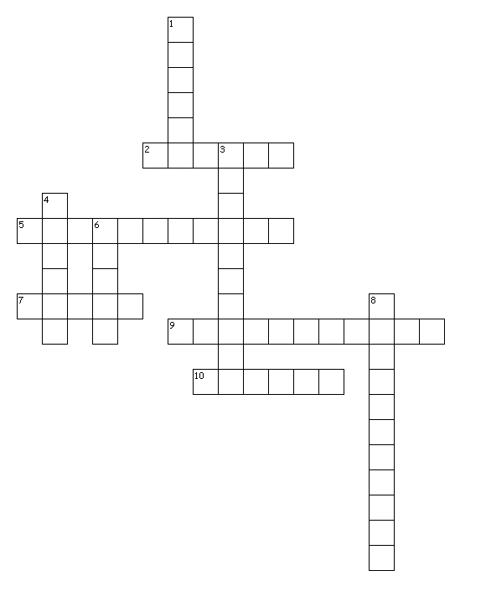

Across
2. extra rules for your area
5. work can not affect this
7. the type of work young workers can do
9. the least you can be paid
10. work can not affect this
Down
1. work can not affect this
3. this can not be affected by work
4. employers need one of these
6. no. of hours you can work at 16
8. a job you can do at 14

- Be able to distinguish between budgeting, savings and debt
Imagine you have a house of your own, a partner, two children aged 7 and 11, a dog and a car. You have a full-time job and earn just over the average salary for the UK, £26,000 per year.

It is vital that you BUDGET effectively so that you do not end up in DEBT. DISPOSABLE INCOME can be spent on luxuries or be put away as SAVINGS

Write definitions for the highlighted words.

BUDGET___________________________________________________________________________________________________________________________________________________________________________________________________________________________
DEBT_____________________________________________________________________________________________________________________________________________________________________________________________________________________________
DISPOSABLE INCOME___________________________________________________________________________________________________________________________________________________________________________________________________________________________
SAVINGS__________________________________________________________________________________________________________________________________________________________________________________________________________________________

Use the house as the centre of a spider diagram. What do you and your family need to pay for every month? Add amounts where you can. You may need to ask your teacher for help.

Have you remembered petrol for the car?
Have you remembered dinner money for the kids?
Have you remembered dog food?

CHECK AS A CLASS.
The EXPENDITURE on your spider diagram (per month) should not exceed your INCOME for the month; otherwise you will find yourself in DEBT.
Calculate your monthly INCOME
(You will need to deduct about a third from your GROSS SALARY for tax and national insurance/pension)
Do your calculations in this box.

My NET income is: £________________________

Calculate your monthly EXPENDITURE
(Add everything from your spider diagram)
Do your calculations in this box.

My monthly EXPENDITURE is: £________________________

Formula Income – Expenditure = DISPOSABLE INCOME

Work out your disposable income.
MY DISPOSABLE INCOME IS £________________ per month.
What might you do with your disposable income?

Remember: When you are in DEBT it is likely that you will repay much more than you owe. When you have SAVINGS your money will work for you.
Work through these examples.
SAVINGS
You have £225 disposable income this month so you treat the family to a night at the cinema and decide to save the remaining £200. The current annual savings rate at your bank is 2.5%.

Your £200 will rise to £__________

Extension – if you do this every month for a year, you will have?
£__________
DEBT
You owe the electricity company £200 and they are threatening to cut off your supply so you borrow £200 from a loan company and agree to pay 27% interest on the amount borrowed.

You pay £________

These payments are added to your monthly expenditure making budgeting even harder.

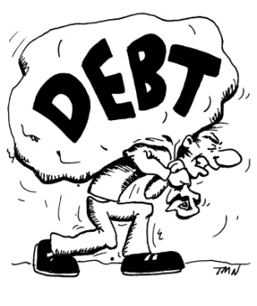

SELF ASSESSMENT
Learning Objective | Evidence (proof)
- Understand the law relating to young people’s permitted hours/types of work

- Be able to distinguish between budgeting, savings and debt

SKILLS USED (circle those that apply) | Working independently analysis  evaluation drawing conclusions  Working collaboratively
Teacher checked: (date) | Signed
Traffic-light Task
Choose RED, AMBER or GREEN. You must complete each colour during the course of the year. Complete your RECORD SHEET once you have made your selection.
RED
Choose two jobs from a particular sector and outline the skills, knowledge and experience necessary for this type of work. Give details about salary, duties and hours of work as well as salary (National Careers Website)
AMBER
Write about your dream job. Give reasons why you chose this job and how you intend to make your dream a reality.
GREEN
Use your knowledge of employment and finance to create a poster for Year 9 pupils which outlines the importance of good GCSE results.

Complete the task on paper and attach to the back of this booklet.

Work-related Learning and Finance VOCABULARY
Peer Assessment. Ask your partner to agree or disagree with your definitions.
Word | Definition | Agreed by
SKILL

EXPERIENCE

VOLUNTARY WORK
SELF-EMPLOYED
FLEXI-TIME

JOB SECTOR

SALARY

DEBT

DISPOSABLE INCOME
NATIONAL MINIMUM WAGE
EXPENDITURE

BUDGET

Jobs

C V N Q Z G G T T W Y K E T Z P E M J P A U G A T
O O E L E C T R I C I A N T R N T O N R Q T E C E
A F T S I T N E D F W T V I G S U C M T Q B H C Y
C F C P A W D K A U W Y S I I R T Y M K K R Q O G
H I H Y T L X C F N V O N N N T M S B H W M W U T
O C Z A L O F Z U L N E O A Z S V Y I H X W T N S
D E R O I P Y W W O E I L L D I M F D G A R D T I
B M K O G R H H F R T I Y D S T F E W J O Y T A R
T A N H T Q D F S P S I G V A N W J C I D L Y N O
F N Z T M A I R E T Q V F O I E D J D H J M O T L
M A I N Y C R C E E X V L B R I E T A K A V Y O F
V G F U E D E T H S Z I B C W C S Z A A B N R R Z
W E G R M R I C S X S O F M E S I Y R I P E I E N
S R L D H G T Y E I J E K A R A G N B E D Z S C Q
J L C K Z F G A S T N V R B C L N Q C L H U W P A
S Y R X B I P A C C Z I F W N F E P I N O C P A T
F Q V A M S F J J Q D V M N I X R U J H U G A D N
R E K R O W Y R E S R U N D B F B R E Y X R V E X
N A I C I T U A E B F E H C A M T R B K F N S C T
S O L I C I T O R A Q A W I C B A E X Y W Z O E Y
K H E R N H Q E M B L N N C R W A Y V C B F K Q V
D I H Y Z L E B P Z T W R H I L E T I P D D V L W
E G T J T N F M C M M I U A A H T Z E W H A Q L D
A J I N B R X H M L C U D I Z T M S S X I R P G H
F A R M E R Y P E F P V H X Q M X G B D Q L W X Z

ACCOUNTANT ADMINISTRATOR AIRCABINCREW ARMY

BEAUTICIAN BUILDER CHEF COACH DENTIST

DESIGNER ELECTRICIAN ENGINEER FARMER

FLORIST HAIRDRESSER JOURNALIST

MECHANIC NURSE NURSERYWORKER OFFICEMANAGER

PRISONOFFICER RECEPTIONIST SCIENTIST SOLICITOR

TEACHER VET WAREHOUSE ZOOLOGIST

Traffic-light Task
Feedback Sheet

FEEDBACK
Teacher Comment | Pupil Comment
WWW

EBI

