Name: _______________________________________________
Class: _______________________________________________
Teacher: _______________________________________________

Understanding Key Terms
Provide a definition for each of the Drama Techniques identified below:

- Tableau
_____________________________________________________________________________________________ [1]

- Slow Motion
_____________________________________________________________________________________________ [1]

- Soliloquy
_____________________________________________________________________________________________ [1]

- Freeze Frame
_____________________________________________________________________________________________ [1]

- Still Image
_____________________________________________________________________________________________ [1]

- Monologue
_____________________________________________________________________________________________ [1]

- Flashback
_____________________________________________________________________________________________ [1]

- Flash forward
_____________________________________________________________________________________________ [1]

- Narration
_____________________________________________________________________________________________ [1]

- Movement
_____________________________________________________________________________________________ [1]

- Mime
_____________________________________________________________________________________________ [1]

- Soundscape
_____________________________________________________________________________________________ [1]

Understanding Stage Space

Research the different stage spaces and add images or draw what each stage space looks like.

- End On Stage

- Theatre in the Round

- Thrust

- Proscenium Arch

- Avenue

- Promenade

Using the stage areas identified in the box, mark the stage below with the correct terms (birds eye view)

Audience

Word search – Characterisation

Word search – Conventions (Techniques)

Word search – Form & Structure

Word search – Language & Voice

Script
Read through the script below,

Script – Mood Board
Create a mood board (collection of 15-20 pictures) that sums up the scene you have read. They could be of the location, themes, characters, feelings…

Script – Costume Design
Design a costume for each of the characters. Don’t forget to annotate your designs and give reasons for your ideas.

Script – Set Design
The script is not set in a particular location. Decide where the scene would take place and design the stage set below.

Script – Sound Design
You need to add sound to your performance to make it come to life for the audience. Create a mind map of the different sounds you would use and justify them below.

Extension Task 1
Many books are turned into plays (films, tv etc.), these are called adaptations. Have a go at creating your own adaptation of your favourite book into a full-scale production.
You will need to create the following designs for your production:
1. Create a set design for your book. This could be a bird’s eye view; a 3D drawing from the audience’s perspective; a series of sketches of the stage layout and the backdrops; or a computer generated collection of pictures to illustrate your ideas. You could even create a live 3D version in miniature—the choice is yours. You should annotate your work, explaining your decisions.
2. Create a costume design for one of the key characters. This could be sketches, computer images, a collage including swatches of fabric; or you could photograph yourself or a family member in the sort of costume you would use. You should annotate your images with suggestions of what colours might suggest or represent, and with any further design notes you want to make that explain your decisions.
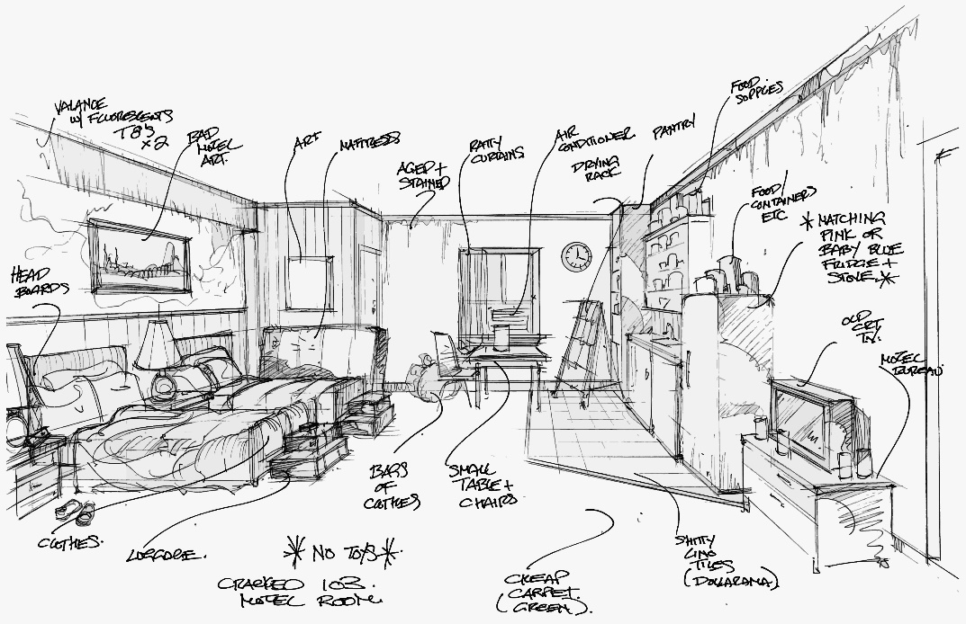
3. Create a poster to promote your performance. This might include sketches, computer images, text and background to your performance ideas. You may wish to look at some existing programmes or posters online to help develop your ideas. You should include annotations to explain your ideas.
