Name:
Teacher:

@WHSTeamEnglish
Year 8 | Literature

Spelling Tests | Score /
Week 1
Week 2
Week 3

Every fortnight you will be expected to complete one section of your literacy booklet.
Tasks will vary and support the skills you are working on in class.

Each homework will contain:
- 1 x Spelling test
- 1 x Literacy activity

You will be given time in lesson to peer mark one another’s work and your teacher will check that you have completed the work to a high standard.

Your teacher will tell you which pathway(s) to focus on and set you a target If you do not manage to meet this target this you will need to re-take the test at another time.
What do I have to do?
Every fortnight you will be expected to complete one section of your literacy booklet.
Tasks will vary and support the skills you are working on in class.

Each week will always contain:
- 1 x Spelling test
- 1 x Literacy Activity

You will be given time in lesson to peer mark one another’s work and your teacher will check that you have completed the work to a high standard.

Your teacher will tell you which Pathway(s) to focus on, and set your target. If you do not manage to meet this target you will need to re-take the test at another time.

What do I have to do?
Why is it important?
Learning at home is very important; it will help you become a more confident learner by developing your key skills within the subject.

In English the purpose of learning at home is to:

- Help you to find time and develop your love of reading outside of the lesson.
- Help you to build confidence in your writing skills.
- Help you to develop your proof-reading skills, which will be crucial across all subjects and in preparation for GCSEs.
Introduction
Week 1 Date of Test: | Read | Write | Cover and write | Definition
Pathway 1/2 | Fiction
 | Chapter
 | Sentences
 | Suggests
 | Surely
Pathway 3/4 | Resolution
 | Chronological
 | Dialogue
 | Exposition (narrative)
 | Frequently
Pathway 5/6 | Perspective
 | Epiphany
 | Definitely
 | Arguably
 | Denouement
Pathway 7/8 | Peripeteia
 | Anagnorisis
 | Anaphora
 | Hypophora
 | Ostensibly
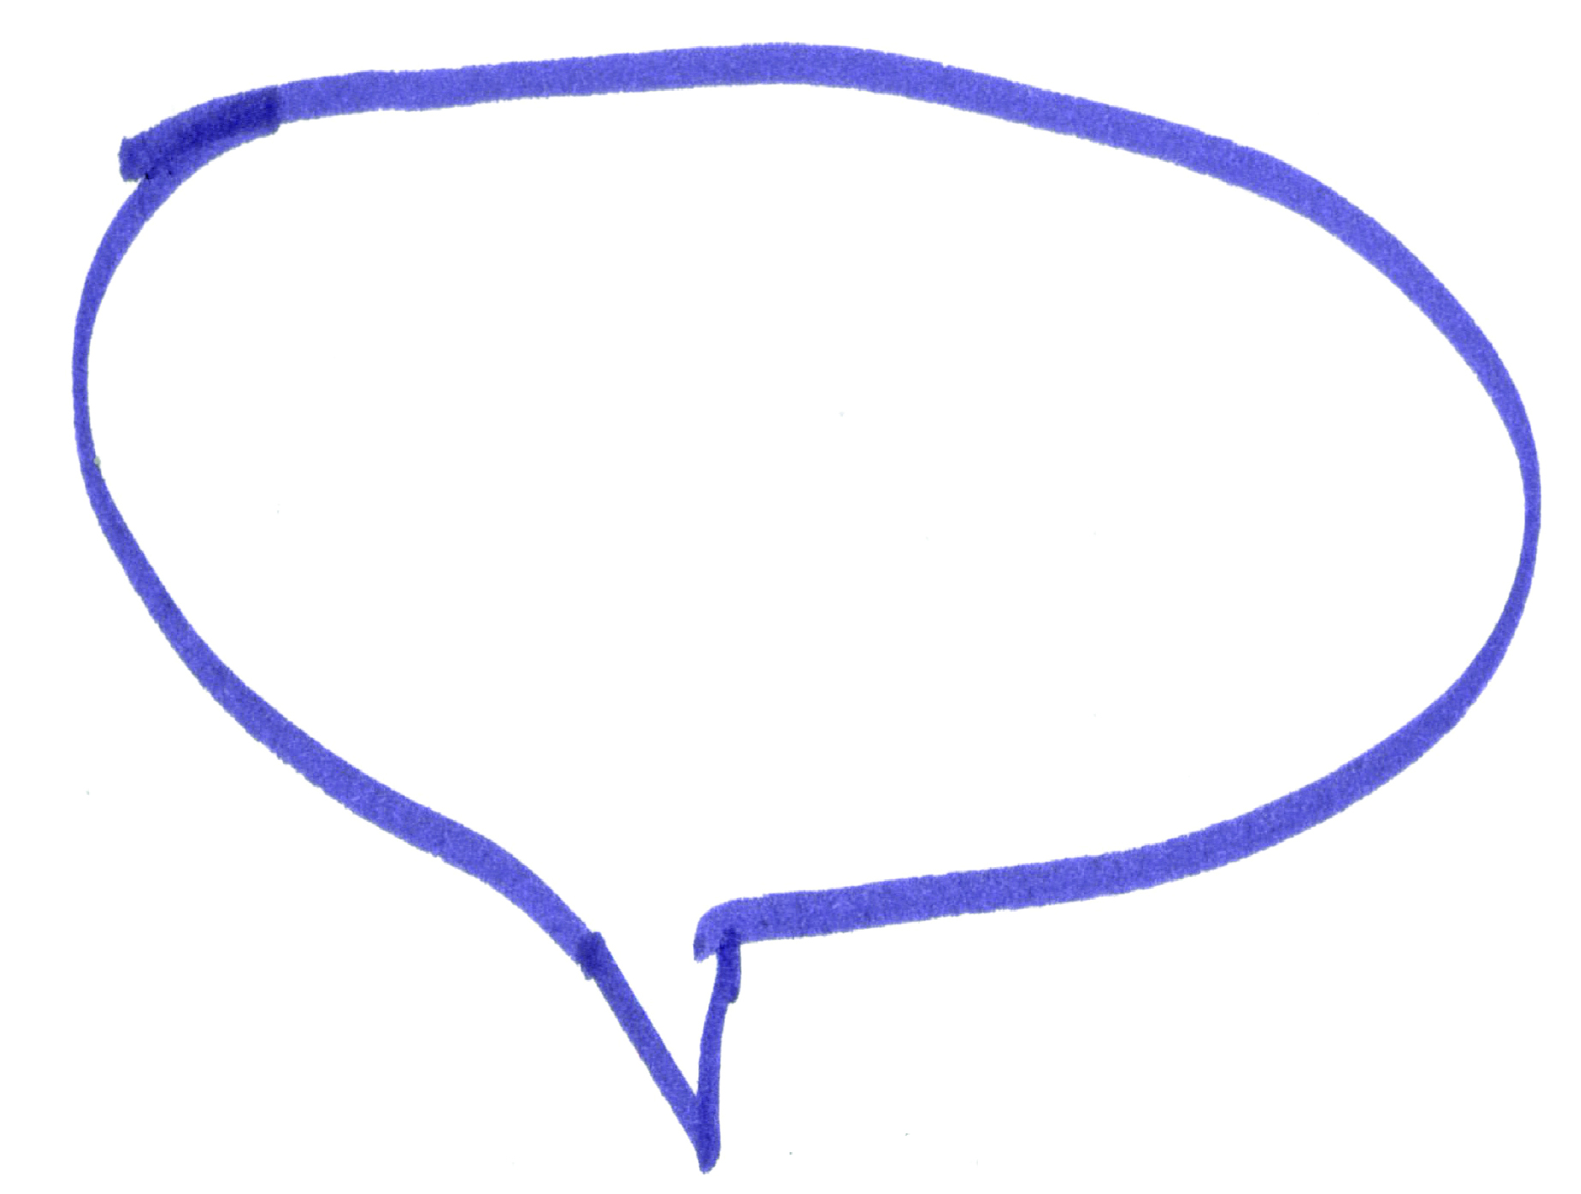
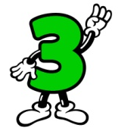
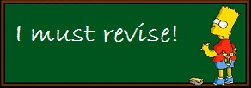
The rules about apostrophes
We have looked at apostrophes in some o the books before but we still need to practise them! Re-read the rules about apostrophes below.
You can also use an apostrophe to show possession, before an s to say that one subject of a sentence owns the next subject in a sentence. For example, Katie’s pencil case – this tells us that Katie owns the pencil case.
Exception to the rule: If the person or subject already ends in an s then the apostrophe comes after the s and no extra s is added. For example, James’ pile of books.
Revising
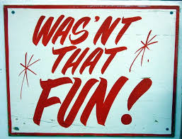
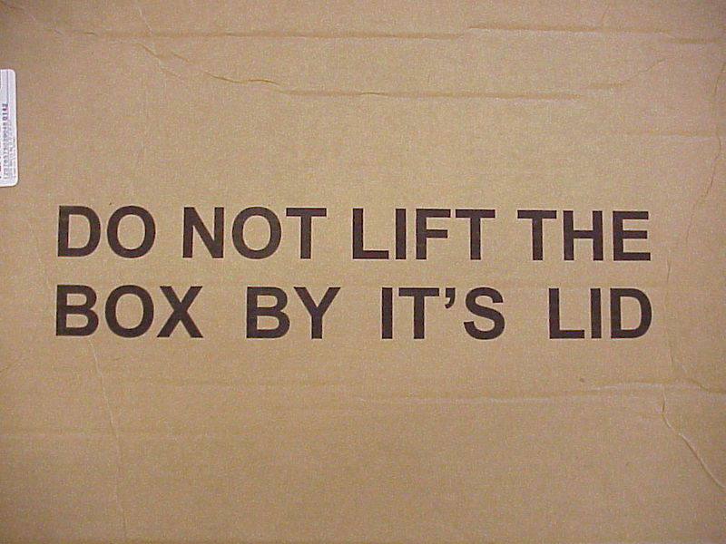
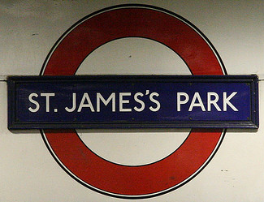
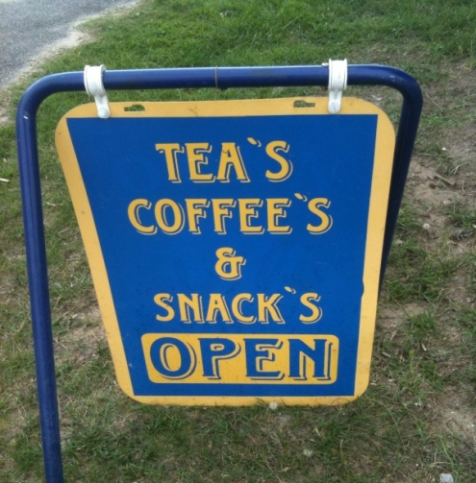
You use an apostrophe in omission – to omit something is to take it away, this is your root word – in this case, when you omit one or more letters. For example, do not becomes don’t – you use the apostrophe in the place of the o here.
You never use an apostrophe when you are talking about a plural, for example, you would have one shoe and two shoes – it would never be shoe’s.
Task:
Can you correct these errors?
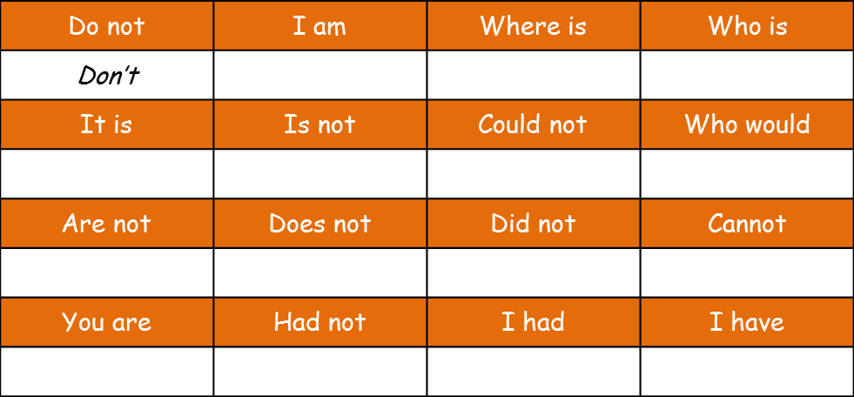
Task 2: Write a short conversation between two friends who are arguing about what to watch at the cinema – you MUST include apostrophes of omission.
If you are writing a formal piece then you should write all words in full. It is considered too informal to use contractions and omissions.
New rule!
Task 1: change these words into shorter words by omitting letters. Replace the missing letters with an apostrophe.

You use an apostrophe in omission – to omit something is to take it away, this is your root word – in this case, when you omit one or more letters. For example, do not becomes don’t – you use the apostrophe in the place of the o here.
We are going to now on rule 2 – omission.
Week 2 Date of Test: | Read | Write | Cover and write | Definition
Pathway 1/2 | Opening
 | Paragraph
 | Flashback
 | Conclusion
 | Flash-forward
Pathway 3/4 | Foreshadowing
 | Typically
 | Motif
 | Cleverly
 | Unquestionably
Pathway 5/6 | Adverbial
 | Characteristically
 | Feasibly
 | Cyclical
 | Prominently
Pathway 7/8 | Exemplifies
 | Epizeuis
 | Polysyndeton (list)
 | Asyndeton (list)
 | Predominantly
Metalanguage
Don’t panic! Look at the root word (language) – we already know what this means. Now look at the prefix – Meta – this means ‘to make aware’. By putting these together it means that we are looking at the language (vocabulary) that describes the way we write and how we construct it.

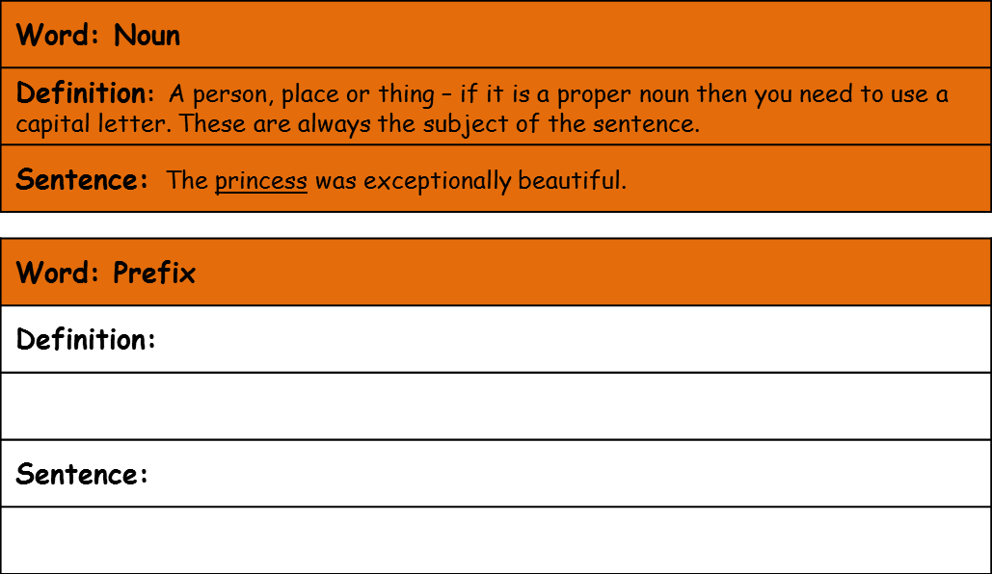
- Find the definition of the word and write it in your own words.
- Write a sentence using the type of metalanguage you have defined. Circle or underline the metalanguage.
By understanding the metalanguage you can understand more clearly how to construct your writing.
For example, if your teacher tells you “You need to add a noun into your sentence to make sure it makes sense” or “you need to add a complex sentence to add more description” then it becomes much easier to begin to tackle the task you have been set.
Why is it important to understand metalanguage?
Word: Hyperbole
Definition:
Sentence:
Word: Verb
Definition:
Sentence:
Word: Pronoun
Definition:
Sentence:
Word: Adverb
Definition:
Sentence:
Word: Superlative
Definition:
Sentence:

Week 3 Date of Test: | Read | Write | Cover and write | Definition
Pathway 1/2 | Repetition
 | Clause
 | Description
 | Highlights
 | Anti-hero
Pathway 3/4 | Certainly
 | Themes
 | Relative clause
 | Dependent Clause
 | Myth
Pathway 5/6 | Perspective
 | Pivotal moment
 | Fatal flaw
 | Anti-climax
 | Catalyst
Pathway 7/8 | Rising action
 | Analepsis
 | Caesura
 | Precursor
 | Indubitably
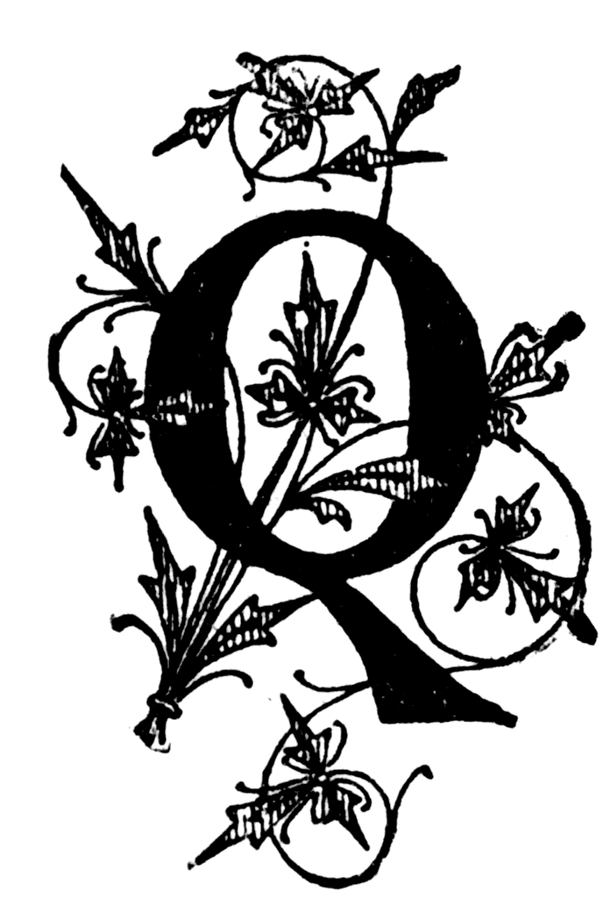
- In section 1 what kind of things can you infer (understand) about ‘Auntie’ Lynn’s treatment of her son? Choose three quotes from the text and explain what they tell you.
- Write a detailed response explaining what you infer about the character of Robin in section 1.
- What is implied about Robin in section 2? Use quotes to back up your ideas.
- Who do you think the narrator is and why? What specific language tells us this?
- Why do you think the writer chose to show the story from this perspective?
- Do you think Auntie Lynn’s protective nature is over the top? Remember to justify your answer in detail.
‘Nothing to be Afraid of’ by Jan Mark
Reading comprehension: Read the extract and answer the questions in as much detail as possible.
Comprehension Activity
uestions
This extract is from the beginning of a novel
Section 1: ‘Robin won’t give you any trouble,’ said Auntie Lynn. ‘He’s very quiet.’

Anthea knew how quiet Robin was. At present he was sitting under the table and, until Auntie Lynn mentioned his name, she had forgotten he was there. Auntie Lynn put a carrier bag on the armchair.

‘There’s plenty of clothes, so you won’t need to do any washing, and there’s a spare pair of pyjamas in case – well, you know. In case...’

‘Yes,’ said Mum firmly [...]

Mum almost told Auntie Lynn to stop worrying and have a good time, which would have been a mistake because Auntie Lynn was going up North to a funeral.

Auntie Lynn was not really an Aunt, but she had once been at school with Anthea’s mum. Robin was not anything much, except four years old, and he looked a lot younger; probably because nothing ever happened to him. Auntie Lynn kept no pets that might give Robin germs, and never bought him toys that had sharp corners to dent him or wheels that could be swallowed. He wore balaclava helmets and bobble hats i winter to protect his tender ears, and a knitted vest under his shirt in summer in case he overheated himself and caught a chill from his own sweat.

Section 2: His face was as pal and flat as a saucer of milk, and his eyes floated in it like drops of cod liver oil; also with extract of milk, concentrated orange juice and calves-foot jelly. When you picked him up you expected him to squelch, like a hot water bottle full of half-set custard.

Anthea lifted the table cloth and looked at him.
‘Hello, Robin.’

Robin stared at her with his flat eyes and went back to sucking his wooly doggy that had flat eyes also, of sewn-on felt, because glass ones might find their way into Robin’s appendix and cause damage.
Answer your questions in detail here:

Peer Marked By:

WWW:

EBI:

