GCSE Computer Science Memory and Storage

Working from home workbook

Your Name: |  | Class:

Due to school closures, self-isolations etc. it is necessary for you to stay away from school and complete work at home. We have tried to make this as easy as possible for you and have provided you with this workbook.
This workbook is designed to be used to help you continue to revise and prepare for your GCSE Computer Science exams.

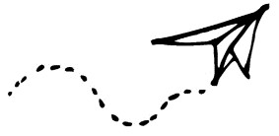

Table of Contents
Memory 3
Storage 4
Recap Memory and Storage 5
Practise Exam Questions 6
Mark Your Exam Questions 7

Instructions:
Work through as many sections as you can. We understand that some of you may be ill during this time or helping to look after others who may be ill, so we ask that you do as much as you can. Obviously the more you can complete, the better you will be prepared for your exams so it is in your own interest to work through as much as you can.
Watch the videos where prompted and complete the tasks that are asked. We have tried to cut down on the printing and paper costs by only including the links to the videos and the tasks and not taken up valuable space with information you can find elsewhere. If you do not have access to YouTube please feel free to use whatever other source of information you have such as textbooks, your own notes etc. to enable you to complete the tasks.
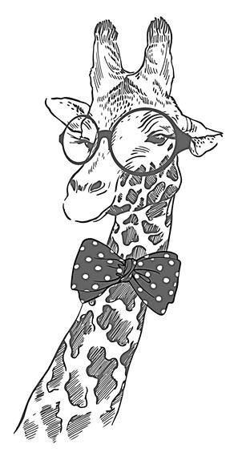
If you have any problems with completing any of the tasks or need any extra help then please contact your teacher however please understand that if they are ill or are looking after somebody else who is ill, they will not be able to give you immediate feedback and you may have to wait for a response.
When you return to school, please bring this workbook with you so your teacher can provide feedback.
We understand this is a difficult time for many but please remain patient and contact your school or teacher if you have any questions or need any additional help.

Memory
https://youtu.be/ZKcgzTYK_Ws

If you don’t have access to YouTube, feel free to look up the information in a textbook or other source.
Now answer these questions:
- What is meant by volatile and what is meant by non-volatile?
- Explain what ROM is used for.
- Explain what RAM is used for.
- Complete the table below to describe the difference between Dynamic RAM and Static RAM.
 | DRAM | SRAM
Where is it commonly used? (Cache or RAM)
Does the information need to be re-written every few seconds or will it stay until the power is switched off?

Storage
https://youtu.be/EpQv_apilkw

If you don’t have access to YouTube, feel free to look up the information in a textbook or other source.
Now answer these questions:
- What is the difference between storage and memory?
- Explain what is meant by the term “disk thrashing”.
- Complete this table:
 | Magnetic | Optical | Solid State
Description
Advantages
Disadvantages

Recap Memory and Storage
You are going to create a memory and storage dictionary. Write descriptions for the following terms in your own words.
Word | Description (in your own words)
Cache
Crash
Disk thrashing
DRAM
GHz
Magnetic Storage
Non-volatile
Optical Storage
RAM
ROM
Secondary Storage
SRAM
Static Storage
Virtual Memory
Volatile

Practise Exam Questions

- Explain the purpose of RAM in a computer system. [2 marks]
...........................................................................................................................................
...........................................................................................................................................
...........................................................................................................................................
- When a user has lots of applications open that they are using, the computer may need to use virtual memory. Explain how virtual memory works and also explain one disadvantage to using virtual memory. [4 marks]
...........................................................................................................................................
...........................................................................................................................................
...........................................................................................................................................
...........................................................................................................................................
- Timothy likes to go skiing and has a helmet mounted camera that he uses to record videos. Identify the type of storage media that is likely to be used in the camera and give two reasons why this is the best type of storage media for a helmet mounted camera. [3 marks]
Type: ...............................................................................................................................
Reason 1: ........................................................................................................................
.........................................................................................................................................
.........................................................................................................................................
Reason 2: ........................................................................................................................
.........................................................................................................................................
.........................................................................................................................................
- Carl wants to back up the data on his computer once a week. Identify 1 advantage and 2 disadvantages of using an optical disk to do this. [3 marks]
Advantage 1: ................................................................................................................
.........................................................................................................................................
Disadvantage 1: .............................................................................................................
.........................................................................................................................................
Disadvantage 2: ............................................................................................................. .........................................................................................................................................

Mark Your Exam Questions
Look back on your answers and mark them using the following criteria.
1) Explain the purpose of RAM in a computer system.
1 mark for any of the following bullet points (max 2 marks)
- RAM holds the programs that is currently in use
- It allows the CPU to access data much faster than from secondary storage

2) When a user has lots of applications open that they are using, the computer may need to use virtual memory. Explain how virtual memory works and also explain one disadvantage to using virtual memory.
1 mark for any of the following bullet points (max 2 marks for how it works and max 2 marks for the disadvantage)

How it works
- An area of secondary storage that stores unused items presently in RAM
- Frees up space in RAM

Disadvantage
- Can make a computer slow to respond…
- … as it takes longer to get data from virtual memory than RAM.

3) Timothy likes to go skiing and has a helmet mounted camera that he uses to record videos. Identify the type of storage media that is likely to be used in the camera and give two reasons why this is the best type of storage media for a helmet mounted camera.
1 mark for any of the following bullet points (max 1 mark for type and max 2 marks for the reasons)
Type
• Static storage

Reasons
- More robust and withstand bumps and knocks
- Light weight
- Can be written and re-written many times

4) Carl wants to back up the data on his computer once a week. Identify 1 advantage and
2 disadvantages of using an optical disk to do this. [3 marks]
1 mark for any of the following bullet points (max 1 mark for an advantage and max 2 marks for the disadvantages)

Advantage
- Cheap
- Highly portable
- Durable against water damage

Disadvantage
- Slow to write to
- Need an optical drive to read and a write it
- Can be easily scratched
- Low capacity

