Personal Development – SMSC/ CEIAG
Next Steps

Contents
Introduction
What should I do next?
Qualifications - why bother?
Qualifications table
So what are your options?
Action Planning

This is YOUR booklet, it is full of useful information, but you should also add in detail where you are asked to do so! You can make notes and highlight key sections or questions you want to ask.
This is important stuff you are dealing with - make the most of this resource!

Introduction
Welcome to Year 9! This is a very exciting year! There is a lot to pack into the Academic year, not only starting your option subjects, but also making choices about your future career paths and being responsible for making your own decisions about your future.
This booklet has been created to help you make fully informed post-16 choices.
As well as information there templates and activities which you should complete.
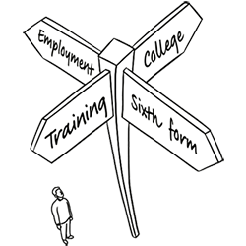
This booklet should remain WITH YOUR FORM TUTOR until it has been completed.
Rules about leaving school
In the past, you had the option to leave school when you were 16. After this you could choose what you wanted to do. However, in 2013, the participation age was raised so you were required to stay in some form of education or training for longer.
Now all young people are required to continue to participate until at least their 18th birthday – and most will stay until the end of that college or school year anyway. This is to give you more skills and options for your future.
Lots of people think these changes mean they need to stay in school. This isn’t the case. There are lots of things that you can do, including:
● full-time study in a school, college or with a training provider
● full-time work or volunteering combined with regulated part-time education or training
● an apprenticeship or traineeship
What should I do next?
Watch this video - https://www.findyourfuture.org.uk/choices-at-16
How many different options can you recall that the people in the video made when they first left school? Write your answers in this box

There are lots of things to think about when you leave school. To help you choose what to do next you might need to think about:
● what career you want to do in the future – some jobs need you to choose certain routes to get into them
● your predicted grades
● whether you want to carry on learning
● how you want to learn – you might enjoy school, and might like to continue; you might prefer more hands-on ways of doing things, so you might want to think about an apprenticeship
Staying at school is one option. But you could also continue your education or training at a college, with a training provider or in the workplace. It is important to choose something that suits your interests and abilities. It's important to know what’s available, but you also need to think about what you would like to do. What are you good at? What do you enjoy? What kind of work would make you happy? Answer the questions on the following page:

What did your choices say about you?
Mostly A’s
Continuing your education or training at school or college seems to appeal to you. If so, you have many choices to research before you make a decision. These will include which subjects and also where you study.
Mostly B’s
Earning while you learn seems to interest you. If so, you have many choices to consider before you make a decision. You should make sure you are researching Apprenticeship and Traineeship opportunities.
Mostly C’s
It sounds like you are not sure what you want to do! You should make sure you are looking at all of the activities in this booklet, as well as speaking to people you trust like teachers, parents, careers advisors and friends to try and help you.
What was your answer?
Has this surprised you, or did you know this is what you wanted to do when you left school?

Do you already have an idea of your post-16 route? Make a note of your ideas and thoughts here:

Qualifications - why bother?
Qualifications are your passport to more opportunities in education, training and work. Here are six good reasons why you should take qualifications seriously

1. To give you a choice of jobs – the number of jobs you can get without any qualifications is shrinking quickly. If you want a choice of jobs, you need good qualifications.
2. To make sure you don’t spend your life in a dead end job – without qualifications, it is hard to move on from a low paid, low skilled job.
3. To improve your earning power – there is a big pay gap between people with qualifications and those without them. If you want a well-paid job, you need good qualifications.
4. To show other people what you can do– qualifications show employers, colleges and universities that you have the attitudes, skills and knowledge they value. They tell them what you already know and can do. They also give them an idea of how well you might do in the future.
5. To prove to other people that you can learn – qualifications show people that you want to learn and that you can learn. Employers, colleges and universities look for people like this.
6. To show yourself what you can do– gaining qualifications boosts your self-confidence and self-awareness.

Level | Qualification example
Entry | Entry Level Award, Certificate, Diploma  Skills for Life or Functional Skills (English, maths, ICT)
1 | GCSEs (grades 3-0)  Award, Certificate, Diploma (City & Guilds, OCR, BTEC/Pearson2)  Music (grades 1-3)
2 | GCSEs (grades 9 - 4)  Award, Certificate, Diploma (City & Guilds, OCR, BTEC/Pearson2)  Intermediate apprenticeship  Music (grades 4-5)
3 | A Levels (grades A-E)  Award, Certificate, Diploma (City & Guilds, OCR, BTEC/Pearson2)  Foundation Diploma (Art and Design)  Advanced apprenticeship  Music (grades 6-8)
4 | Higher National Certificate (HNC)  Certificate of Higher Education (CertHE)  Higher apprenticeship
5 | Higher National Diploma (HND)  Diploma of Higher Education (DipHE)  Foundation Degree
6 | Degree with Honours (eg BA Hons, BSc Hons)  Degree apprenticeship  Graduate Certificate or Graduate Diploma  Ordinary Degree (without Honours)
7 | Postgraduate Certificate/Diploma  Master’s Degree (eg MA, MSc, MBA, MPhil)  Integrated Master’s Degree (eg MEng)  Postgraduate Certificate in Education (PGCE)  NVQ Level 5
8 | Doctorate (eg PhD, DPhil, EdD, DClinPsy)
Qualifications Table
It can appear a little confusing at first, as all qualifications are given a Level, and depending on what you are applying for - there might be a different qualifying Level. Use the table below to help you understand the different Levels.
Qualification Challenge!
Use the table on the next page to help you answer these questions on qualification levels.
- What level is a GCSE Grade D?

- What Grade of Music would be considered a Level 3?

- What is the highest qualification on this table?

- What level is an intermediate apprenticeship?

- What is the highest level you can achieve with an NVQ?

So what are your options?
There are four main pathways for you to consider. These are
● College - A Levels (Level 3)
● College - Vocational BTEC (Level 1/2/3)
● Apprenticeships/Traineeships (Level 2/3/4)
● Employment/self-employment
Next read through the following pages and use this space to capture key information about each pathway (aim for at least 3 key things about each pathway).
DON’T FORGET - these are your own notes, write down the things which YOU think are important, and that might influence your decision when choosing a pathway.

Apprenticeships and Traineeships http://www.apprenticeshipguide.co.uk/
Want to leave school, or already left and looking for work? There is a good way to earn money and learn at the same time. On an apprenticeship you will be employed in a real job and receive quality training to help you get a nationally-recognised qualification.
If you're not quite ready for an apprenticeship, on a traineeship you can improve your maths, English and work skills whilst getting work experience too.
Even though the school leaving age has gone up, you can leave from age 16 if you’re going into training or employment. This means you have to make a quicker decision about what you want to do than your friends staying in full-time education. It’s important to get it right and look at up-to-date information, as things can change.
What is an apprenticeship?
An apprenticeship is a real job with training so you can earn while you learn and get recognised qualifications as you go. They take between one and four years to complete. Your employer provides your on-the-job training and pays your wages. You will work alongside them and learn from some of the best in the business.
Your learning provider can be a college, training organisation or university, and they look after the rest of your training. You can complete this off-the-job training on day release (attending one day a week) or over a succession of days in a short period (block-release).
Which qualifications will you get?
● Intermediate – work-based learning towards level 2
● Advanced – work-based learning towards level 3
● Higher – work-based learning towards level 4 and higher
Who can take an apprenticeship?
● need to be 16 or over
● depends on level: for an apprenticeship at Advanced level, most employers want level
2 (C @ GCSE) or level 3 qualifications including level 2 maths and English, or a pass in literacy and numeracy tests
How long does it last? One to four years.
How much will you earn? Minimum wage, most pay more – average is £170 a week
How much will it cost? There are no fees if you are under 24 years old. Those aged 24+ have to make a contribution to their training costs.
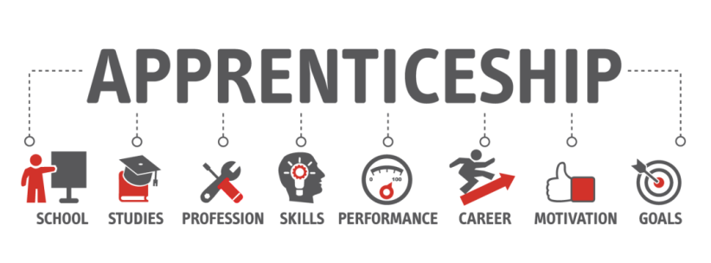
What types of apprenticeship are on offer? Many employers offer both traineeships and apprenticeships – so you may be able to move to the next level with the same employer. It’s no longer just construction and engineering that are on offer, although those are still around if you’re interested. Now you can go into 170 industries with 1400 different job roles such as design assistant, cabin crew, dental nurse or trainee accountant.

Traineeships
What is a traineeship?
A traineeship is effectively a lower entry level Apprenticeship. This is a pathway which you could consider if you do not meet the qualifying criteria for an Apprenticeship. Traineeships are a fantastic way to gain valuable work experience and improve your qualification level.
What you can expect from a Traineeship
● high quality work placements – where you can learn what’s expected of you in the workplace, and develop links with local employers
● flexible training - in other relevant areas to help you get ready for work, such as job search and interview skills, time-keeping and team working
● study in English and maths (if appropriate) – employers value these essential skills very highly.
At the end of your traineeship, if there is a job or apprenticeship vacancy with the work placement host, you should receive an interview. If there isn’t a job or apprenticeship opportunity at that time, you will receive an exit interview with the employer who provided the work placement. In this interview you can discuss what you’ve learned, and how it might help you with things like updating your CV and getting into a job or an apprenticeship.
Whether you go for a traineeship or apprenticeship will depend on your age and qualifications. Read on for the basics on traineeships.
Who can take a traineeship? You must be:
● 16-24yrs and qualified below level 3
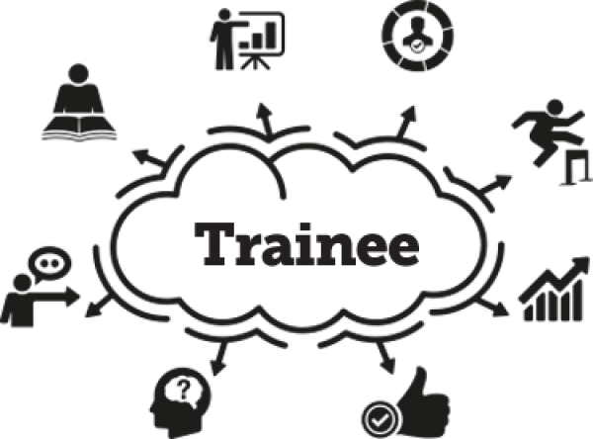
● 16-25yrs with learning difficulties.
How long does it last? Six weeks to six months.
How much will you earn? Traineeships are unpaid but most pay travel and meal costs. The 16-19 Bursary Fund may help – it depends on your circumstances whether you get it or not.
What types of traineeship are on offer?
Many employers offer both traineeships and apprenticeships – so you may be able to move to the next level with the same employer. It’s no longer just construction and engineering that are on offer, although those are still around if you’re interested. Now you can go into 170 industries with 1400 different job roles such as design assistant, cabin crew, dental nurse or trainee accountant.

Further Education College (FE)
What is a further education college?
Further education (sometimes referred to as FE) colleges are for students aged 16 and over so you could study alongside people of all ages. Further education colleges often offer you a much wider choice of courses at all different levels, including A levels and vocational qualifications. It’s worth exploring the different courses they offer. Many of you will have already visited some of our local colleges to experience their learning environments.
What is the environment like?
It’s likely that you’ll find the atmosphere at a further education college different from that of school. It will probably be more laid back, you’ll be able to wear your own clothes, be in charge of your own time when you’re not in lessons, and maybe even call your tutors by their first names!
You’ll still be expected to stick to a timetable and attend lessons, but you might not have to stay in college during your free periods. You’ll be given a lot of independence and expected to manage your own time. Everyone is different - would this way of working suit you? Think about that when you decide what kind of environment will inspire you.
What if I want to go to college away from home?
If they will accept you, you can apply to any college you fancy. You might want to study a particular course which is only available at a college which is outside of your local area. However, if you want to move away from home to study there are a couple of things you will need to consider:
● where you are going to live
● how you are going to pay your living expenses.
If you move away from home because the course you want to do isn’t offered any nearer to where you live, you could get help with this. Ask the college you wish to go to for information about any help that may be on offer, like the Residential Support Scheme or Residential Bursary Fund.
Further Education College (FE): A Levels
Watch this short video on A Levels: https://youtu.be/BHKFrXMCHII
A Levels are a two year course, which are focused on one subject (such as English Literature). They are a mixture of Exams and Coursework. Normally you will be asked to select three or four A Level subjects.
The reason you take a particular subject is usually one (or more) of these three scenarios: you need it to pursue a particular career or University place; it’s a subject you enjoy and are good at; or it’s a subject you’ve not studied before but you think will suit you.
Either way, be prepared for a big jump in the level of difficulty when you transition from GCSE to A Level (or any other Advanced level qualification for that matter). You’ll also see differences in the way you’re taught and in what is expected of you.
Further Education College (FE): Vocational (BTEC)
BTEC stands for ‘Business and Technology Education Council’, named after the body which first governed the qualifications (it’s now Edexcel). BTECs are gaining popularity as an alternative to A-Levels, but they actually cover a whole range of academic levels. BTECs at levels 1 and 2 are equivalent to GCSEs, level 3 to A-Levels, and levels 4 -7 hold the same status of achievement as a degree.
BTECs are vocational qualifications, rather than traditional academic courses, with typical subjects offered at BTEC level including Business Studies, Travel and Tourism, Engineering and Information Technology – you can’t study subjects like History or English at BTEC level.
One of the main differences between BTECs and A-Levels is the way both are assessed.
A-Levels mainly involve two years of study geared towards a few big tests at the end, whereas BTECs are continually assessed via coursework and practical projects.
Employment
Due to recent changes in the law any full time employment which you undertake before the age of 18 must also contain some element of training. Because of this, school leavers going into full time employment is now quite rare. Most people would opt for an Apprenticeship - and this is something which you should consider to.
However if you are itching to get out there and earn your own money, there is the option of part time employment. As well as helping you to get that bit of extra hard earned cash, part-time job can be a great way of getting experience and learning new skills. It’s also a way of meeting new people and making contacts that could be useful later on in your career. You will find loads more information about part time working later on in this booklet.
Self-Employment
If you’ve always fancied being your own boss or have interests and hobbies that you would like to turn into working for yourself, then read on for some advice on where to start.
What you will need
From a practical point of view there are a few things you will need to think about when you set up your own business. These can include:
● what products or services you will sell
● will people want your service or product
● how you will fund your business
● which laws and regulations will you need to follow.

Start-up advice and funding
There plenty of places to get help and advice on setting up your own business. Visit the GOV.UK website to help you start thinking about the practical things. If you’re still in school, college or at university you could learn more about business and get a taste of setting up your own venture through the Young Enterprise scheme. Visit their website or ask your careers teacher for more information.
Start Up Loans is a government-backed scheme. If you’re 18 or over you can apply for low-cost loans and business mentoring to help you start your business. They’ll also help you to develop a business plan. Take a look at their website for more information.
If you have a business idea you want to explore, are aged between 18 and 30, are unemployed or working less than 16 hours a week, the Prince’s Trust Enterprise Programme could be for you. It can offer you training, mentoring and funding support so that you know what to expect, how to develop a plan for your business and how to market it.
Shell LiveWIRE is an online community for young entrepreneurs aged 16 to 30. It offers online advice through resources like articles and blogs. They also offer business start-up awards to young business people in the UK. Check out their website for award entry criteria and more information.

Weighing it up
It’s worth taking some time to think about what being self-employed will mean to you and whether it will give you what you are looking for from a career. Take a look at some of the common pros and cons of working for yourself. You may be able to think of some more of our own.
Pros | Cons
- be your own boss  - do something you love every day  - have more flexibility on when you work  - make more money when your business  is successful  - freedom to make your own business  decisions  - set up a business offering a specialist  service or product. | - no paid holidays or sick leave  - lack of a regular, guaranteed income  - have to arrange payment of tax, VAT  and National Insurance yourself  - work long hours to meet the needs of  customers or clients  - can be lonely if you work by yourself  - risk of failure

Year 9 Action Plan: Next steps Term 1
Where am I now?
What skills and qualities do I have? What am I good at?  How might they help me achieve my careers ideas? | e.g. you could include hobbies, spare time interests; sporting interests and successes, your personal skills (do you get on well with people?)  What sort of person are you? What are your best subjects? Have you held posts of responsibility such as team captain?

How might this affect my careers ideas? | What are your worst school subjects? What don’t I like doing?

When I think about careers, these are the things that matter to me: | e.g. meeting people, helping people, outdoor work, using maths, science related, being creative, being practical, writing

Action Plan: Next steps
Where do I want to be?

My career ideas at the moment are - | You may have definite career plans. What are they? You may have 1 or 2 ideas but not sure how to choose. You may have no idea at all. Make some notes below,

What do I already know about my careers ideas? | Help  What qualifications do you need? Do you need any special qualities or skills?  How do I go about applying?

Write any extra ideas or recent achievements in the space below:

Where am I at the end of Year 9 | e.g.  List your Option Subjects
Action Plan: Next steps
Year 9 Term 3 Review

Why have you chosen them?  How have you found them this year? | e.g.  - because you are good at them?  - because they help your career plans

What further action do I need to take before Year 10? | e.g.  Talk to parent/guardian. Find out information in the Careers Library. Speak to subject teachers/tutor.  Use Careers Computer Software  See Careers Advisor

This Action Plan was reviewed on ____________________ (date)
Signature: _____________________________________ (pupil)

