Cambridge Nationals Sports Studies

R051 – Contemporary Issues

Student Name:
Class:
Teacher:
Target:

LO2
The use of performance enhacing drugs in sport

LO2
The use of performance enhancing drugs in sport

Topic | Covered? | Confident?
Reasons why performance enhancing drugs are used
Reasons against the use of performance enhancing drugs
Drug offences by elite performers
The role of WADA in stopping PEDs
Impact of drugs on the reputation of a sport

Date:________________________________
Using performance enhancing drugs in sport
Key Learning:
- Identify and describe the reasons for and against taking PED’s
- Identify athletes who have committed drug offences in sport.
- Explain the consequences of using PED’s by elite performers

What is a performance enhancing drug (PED)?
___________________________________________________________________________
___________________________________________________________________________
___________________________________________________________________________

Task
Using the sheet, identify the different reasons why an athlete would take performance enhancing drugs vs why they would not.

Why would an athlete take performance enhancing drugs?

Why would an athlete NOT take performance enhancing drugs?
Apply your learning!
Task
Scenario: You have just qualified for the Olympics in 6 months’ time. You have secretly been offered to take a PED in the lead up to your event at the Olympics.
Task: Describe in detail the potential positives and negatives of taking the PED.
STRETCH: Provide examples for each reason described.

___________________________________________________________________________
___________________________________________________________________________
___________________________________________________________________________
___________________________________________________________________________
___________________________________________________________________________
___________________________________________________________________________
___________________________________________________________________________
___________________________________________________________________________
___________________________________________________________________________
___________________________________________________________________________
___________________________________________________________________________
___________________________________________________________________________
___________________________________________________________________________
___________________________________________________________________________
___________________________________________________________________________
___________________________________________________________________________
___________________________________________________________________________
___________________________________________________________________________
___________________________________________________________________________
___________________________________________________________________________
___________________________________________________________________________
___________________________________________________________________________
___________________________________________________________________________
___________________________________________________________________________
___________________________________________________________________________
___________________________________________________________________________
___________________________________________________________________________
___________________________________________________________________________
___________________________________________________________________________
___________________________________________________________________________

Drug Offences by elite performers

Who are the following athletes?
What sport do/did they participate in?

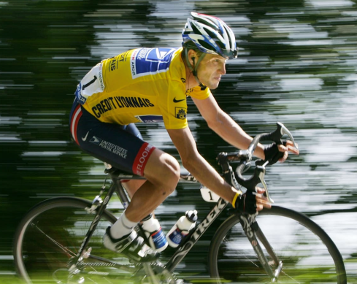
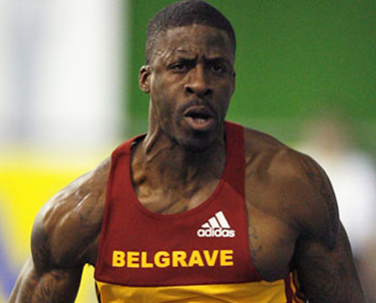

Name: ___________________

Sport: ___________________
Name: ___________________

Sport: ___________________

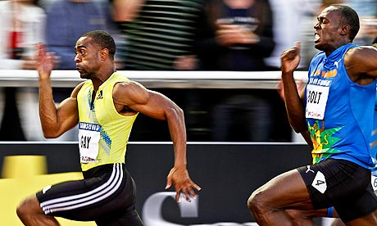
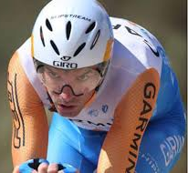

Name: ___________________

Sport: ___________________
Name: ___________________

Sport: ___________________

Task
Complete the table by answering the following questions:
- What sport do/did they take part in?
- What performance enhancing drug did they take?
- Why do you think they did it?
- What were the consequences?
- How fair do you think this is? Why?

Sports Person | What sport do/did they take part in? | What performance enhancing drug did they take? | Why do you think they did it? | What were the consequences? | Do you think this punishment was fair? Why?
Dwain Chambers

David Millar

Lance Armstrong

Tyson Gay

Apply your learning!
Give two reasons why an elite performer might take performance enhancing drugs.
- ____________________________________________________________________
______________________________________________________________________________________________________________________________________________________
- ____________________________________________________________________
______________________________________________________________________________________________________________________________________________________
STRETCH
Can you think of any more reasons why an athlete would take PEDs?

Can you identify any specific sporting examples?

Can you explain what impact this may have on sport?

___________________________________________________________________________
___________________________________________________________________________
___________________________________________________________________________
___________________________________________________________________________
___________________________________________________________________________
___________________________________________________________________________
___________________________________________________________________________
___________________________________________________________________________
___________________________________________________________________________

Improve your answer
___________________________________________________________________________
___________________________________________________________________________
___________________________________________________________________________
___________________________________________________________________________
___________________________________________________________________________
___________________________________________________________________________
___________________________________________________________________________
___________________________________________________________________________
___________________________________________________________________________
___________________________________________________________________________
___________________________________________________________________________
___________________________________________________________________________
___________________________________________________________________________

Date: __________________________________

Silent Starter

1. What is NOT a reason to take performance enhancing drugs?  - Financial benefits from success  - Enable them to train harder  - Develop their technical skills  - Boost their physical performance | 5. What is an emerging sport?  - A new sport in the U.K. that does not have many participants.  - A traditional sport that has been played for a long time in the U.K. that has recently become more popular.  - A new sport in the U.K. that has enjoyed increased popularity and rising participation in recent years.  - A new sport in the U.K. with no tournaments or competitions in place as yet.
2. The athletes parade during the opening ceremony best demonstrates which Olympic value?  - Excellence  - Determination  - Inspiration  - Courage | 6. A teenager spends their spare time volunteering as a coach. Which value is this an example of?  - Excellence  - Citizenship  - Team Spirit  - Tolerance and Respect
3. Which is an example of gamesmanship?  - Arguing with the referee  - Timewasting by kicking the ball out of play  - Pulling the shirt of an opponent  - Fouling an opponent | 7. The Olympic symbol of five interlocking rings represents …..  - The number of Olympic values  - Five continents that take part  - Five different ethnic groups  - Five different categories of Olympic events
4. Work commitments can be a barrier to participating in sport. Which of this is a solution to this barrier?  - Increased variety of sports  - Advertising using role models  - Reduced pricing  - Better programming of sessions | 8. Which best matches the Olympic creed…  - Breaking a world record  - Winning a gold medal  - Finishing a race after falling badly  - Finishing 1st in a relay race

How are athletes stopped from taking performance enhancing drugs?
Key Learning:
- Identify different ways to conduct drugs testing
- Identify and describe how WADA stop athletes from taking PEDs
- Explain the impact that PEDs have on the reputation of sports

WADA

Who are WADA?

What are the three ways that WADA prevent drugs in sport?

Methods of detecting performance enhancing drugs in sport

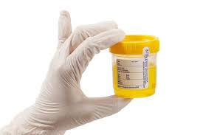
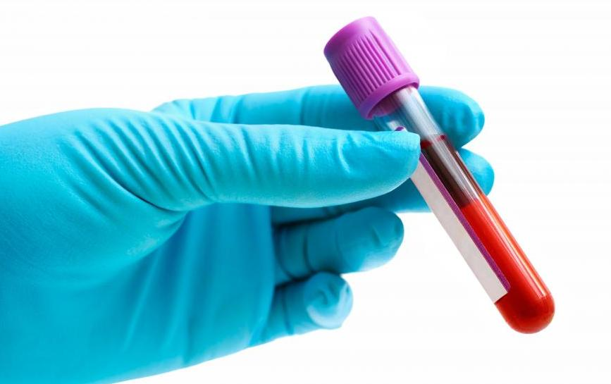

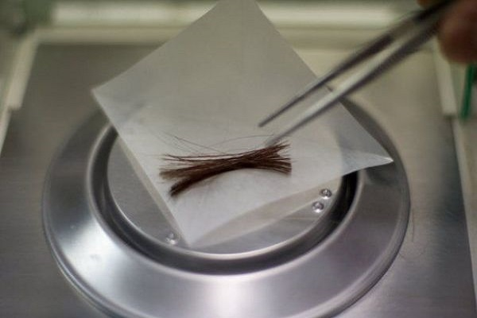
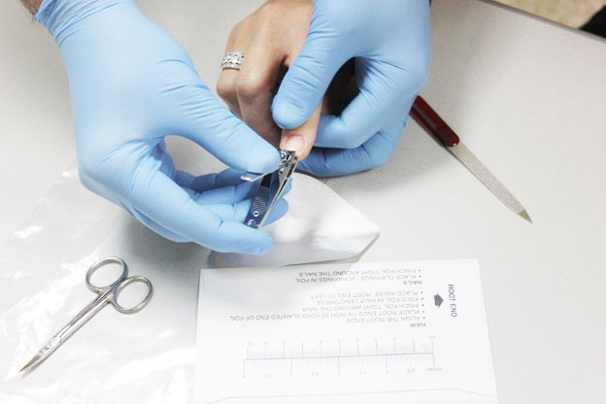

The Wherabouts Rule

- _________ competition drug ___________
- Performers must inform their ______ of their ___________ out of competition
- Athletes must provide ______ time slot every ______ of where they will be.
- This is so they can be _______________________ at any time.
- _______ missed tests in a year results in a ____________.

Methods to prevent performance enhancing drugs in sport

Method | Description | Details

Impact on the reputation of the sport
Task
There are 8 impacts that can effect the reputation of a sport because of PEDs.
Can you match up the impact to the description / example?
STRETCH: Can you add your own examples.

Impact | Description / Example

Task
Complete the Super 6 questions in your exam practice books based on performance enhancing drugs

