Cambridge Nationals Sports Studies

R051 – Contemporary Issues

Student Name:
Class:
Teacher:
Target:

LO3
Understand the importance of hosting major sporting events

LO3
Understand the importance of hosting major sporting events

Topic | Covered? | Confident?
The features of major sporting events
Potential legacy of major sporting events
Benefits of hosting major sporting events
Drawbacks of hosting major sporting events

Date:________________________________
Features of major sporting events
Key Learning:
- Identify the features of major sporting events
- Describe the potential legacy of major sporting events.
Silent Starter
How many major sporting events can you identify?
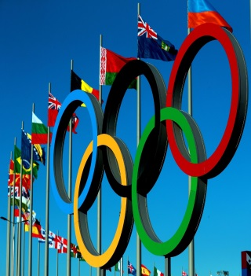
- Olympics

Types of major sporting events
One Off events – _____________________________________________________________________________________________________________________________________________________________________________________________________________________________________________________________________
Regular events -
_____________________________________________________________________________________________________________________________________________________________________________________________________________________________________________________________________
Regular and recurring events -
_____________________________________________________________________________________________________________________________________________________________________________________________________________________________________________________________________

Task:
For each event, decide if it is a one off, regular or regular recurring event and explain why you have chosen this type of event.

Event | Type of Event | Reason
 | Regular and Recurring | The Wimbledon Tennis championship are held every July at Wimbledon.
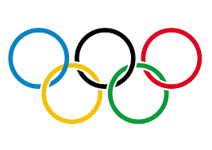
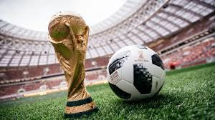

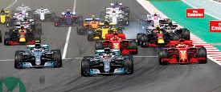
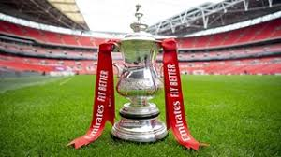

The International Element

An event can involve participation from different countries. The features of international events are:

- Involves competitors from different countries
- Involves spectators from more than one country
- High levels of investment required
- Generates lots of media coverage
- Can be a one-off or recurring event

Circle the examples of international events
Champions league final

British F1 Grand Prix Wimbledon

FA Cup Final Super League Grand Final

Level of Investment
Major Sporting events require a significant amount of investments to be a success. The investment is split into two categories: Required investment and Funding attracted for the event.
Required Investment
Major Sporting events can cost millions and evening billions of dollars and millions, even billions, of dollars are needed to put on a major sporting event.
Funding Attracted
Sponsors play a huge role in supporting a major sports event. Sponsorship can be shown through the act of supporting an event, activity, person or organisation through the provision of finance.
Task: Can you match the official partners to the correct event:

FIFA World Cup | Wimbledon | Formula One

STRETCH: Why would major companies choose to sponsor these types of events?

Potential legacy of events
Legacy of London 2012
Regeneration of homes around the Olympic park

Types of legacies of major sporting events
Legacy - ______________________________________________________________________________________________________________________________________________________
There are 3 types of legacies that are left after a major sporting event:
- Sporting – inspires a generation to participate in the sport.
- Social – improves the well-being in society.
- Economic – encourages economic growth after the event has finished.
Task:
Read each of the statements that give different potential legacies from a major sporting event. Work out which type of legacy each statement is.

Sporting Legacy | Social Legacy | Economic Legacy

Apply your learning – Exam Question

Identify whether the following long term benefits of hosting a major sports event leave an economic or sporting legacy. Tick the relevant column to indicate your answer.
Benefit | Economic | Sporting
Income for local businesses
‘Shop Window’ effect for the country
New sporting facilities that can be used by the local population after the event.
Increase participation in some sports
Development of community sport
Increase in tourist spending

Date:________________________________
Benefits and drawbacks of hosting major sporting events
Key Learning:
- Identify the benefits and drawbacks of hosting major sporting events
- Describe the reasons why they are benefits or drawbacks.
- Evaluate the impact of benefits and drawbacks.
Silent Starter
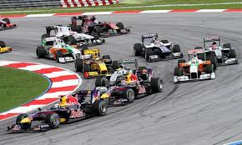
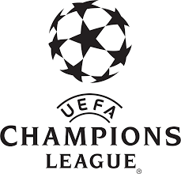
What are the features of these events?
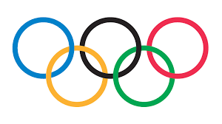

Event:

Features:

Event:

Features:

Event:

Features:

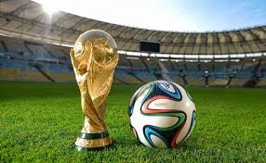

Event:

Features:

Event:

Features:

Event:

Features:

Benefits of hosting major sporting events
Benefit of hosting a major sporting event | Reason why this is a benefit | Social/ Sporting or Economic legacy benefit
Investment in developing and improving transport system | Improving train lines could help commuters have a better journey to work and improve the general transport links to other cities. | Economic / Social
Increased tourism
Commercial benefits (e.g money from sponsors)
Participation in sports may increase
Sports facilities will be improved or new facilities built
Raise the status of the country/‘shop window effect’

Morale of the country is raised (National pride)
Provides employment for local people

Drawbacks of hosting major sporting events
Drawbacks of hosting a major sporting event | Reason why this is a benefit | Social/ Sporting or Economic legacy benefit
Expenses when bidding for event | Bidding to host can be expensive and you may not be awarded the event | Economic
Costs of event
Facilities not used

Status of the country impacted
Sport popularity may suffer
Negatively impacts the status of country

Apply your learning – Essay Style Exam Question
‘Evaluate the social, sporting and economic impact of hosting the Olympic Games’ (8 marks).
To do this we need to know and understand:
- What are social, sporting and economic legacies?
- The advantages and disadvantages of hosting a major sporting event
- Sporting examples of places that have hosted the Olympic Games and the impact of this

Evaluate the social, sporting and economic impact of hosting the Olympic Games
(8 marks)
Key:
Paragraph 1 Paragraph 2
Paragraph 3
Point:
Advantages:
- Improved transport system
- Increased direct and indirect tourism
- Commercial benefits e.g. money from sponsors, external investment which would not otherwise have been attracted
- Increased participation in some sports
- New facilities can be used again by people in local area
- Improved sports facilities
- Raise the status of the country / shop window effect
- Morale of the country is raised
- Provides employment for local people
Disadvantages:
- Bidding to host the event is expensive and you might not win the bid
- The event can cost more to host than the amount of money it actually raises
- Facilities can end up not being used
- Negatively impacts status of country if the event is run poorly or is disorganised
- Other sports that are not the focus may suffer as a consequence
- Can cause divisions in the country if only one city is perceived to be benefitting from it
Evidence:
London 2012 – Advantages
“The Games inspired people to take up coaching and volunteering roles in their local communities”
“The Olympic Stadium is now home to West Ham United and numerous athletics competitions.”
“46,000 jobs were created and 10% of these were previously unemployed”
“The UK economy has seen a £9.9 billion trade and investment boost from hosting the Games
“1.4 million more people are now taking part in sport every week.”
Rio 2016:
Disadvantages
“Rio is $31 billion dollars in debt”
“3,600 empty apartments in the boarded up Olympic village”
“Half a dozen empty sports arenas and most are vandalised”
“The improvements only benefit the wealthy people in Rio”
“Public sector workers wages and pensions have been cut”
“Crowding on the new express buses and a lack of security”
Model paragraph:
One social advantage of hosting the Olympic Games is it provides employment for local people. An example of this was at the London 2012 Olympics where 46,000 jobs were created where 10% of these people were previously unemployed. This created a positive social legacy in London because jobs provide people with skills and makes them feel happier.
On the other hand one social disadvantage of hosting the Olympic Games is it can cause divisions in the country if only one city is perceived to be benefitting from it. An example of this was at the Rio 2016 Olympics where the improvements that were made were seen as only benefitting the wealthy people. This created a negative social legacy in Rio because the poor people in Brazil felt that they were being treated unfairly as they could not afford to access or use the new facilities.
Explain the impact:
This created a positive social legacy in London because….
This created a negative social legacy in Rio because….
This created a positive sporting legacy in London because….
This created a negative sporting legacy in Rio because….
This created a positive economic legacy in London because….
This created a negative economic legacy in Rio because…

‘Evaluate the social, sporting and economic impact of hosting the Olympic Games’ (8 marks).
………………………………………………………………………………………………………………………………………………………………………………………………………………………………………………………………………………………………………………………………………………………
………………………………………………………………………………………………………………………………………………………………………………………………………………………………………………………………………………………………………………………………………………………
………………………………………………………………………………………………………………………………………………………………………………………………………………………………………………………………………………………………………………………………………………………
………………………………………………………………………………………………………………………………………………………………………………………………………………………………………………………………………………………………………………………………………………………
………………………………………………………………………………………………………………………………………………………………………………………………………………………………………………………………………………………………………………………………………………………
………………………………………………………………………………………………………………………………………………………………………………………………………………………………………………………………………………………………………………………………………………………
…………………………………………………………………………………………………………………………………………………………………………………………………………………………………….
………………………………………………………………………………………………………………………………………………………………………………………………………………………………………………………………………………………………………………………………………………………
………………………………………………………………………………………………………………………………………………………………………………………………………………………………………………………………………………………………………………………………………………………………………………………………………………………………………………………………………………………………………………………………………………………………………………………………………………………………………………………………………………………………………………
………………………………………………………………………………………………………………………………………………………………………………………………………………………………………………………………………………………………………………………………………………………
………………………………………………………………………………………………………………………………………………………………………………………………………………………………………………………………………………………………………………………………………………………

MR GLOVER’S PERSONALISED FEEDBACK
LO3 – Hosting Major Sporting Events
What Went Well (WWW)
If highlighted well done, if not rectify it.
- All work is readable.
- All work is completed in black pen.
- All work has a date.
- All work is finished.
- Identified the features of major sporting events
- Described the potential legacies of major sporting events.
- Identified and described the benefits of hosting major sporting events
- Identified and described the drawbacks of hosting major sporting events
- Applied knowledge to exam questions
Even Better If (EBI)
To improve your work you need to add more detail to the following areas of your work
- Identifying the features of major sporting events
- Describing the potential legacies of major sporting events.
- Describing the benefits of hosting major sporting events
- Describing the drawbacks of hosting major sporting events
- Applying knowledge to exam questions
Identify Questions (Bronze)
- Identify, with examples, the different types of major sporting events.
- Identify the three types of legacies of a major sporting event.
- Identify three benefits of hosting a major sporting event
- Identify three drawbacks of hosting a major sporting event
Describe Questions (Silver)
- Define the three types of major sporting events. Give an example for each.
- Describe three aspects of the legacy requirements when hosting a major sporting event.
- Describe three benefits of hosting a major sporting event.
- Describe three drawbacks of hosting a major sporting event
Explain Questions (Gold)
- Explain the possible economic benefits and economic drawbacks for a country before, during and after hosting an Olympic Games.

MAKE IT BETTER

REMEMBER TO USE YOUR GREEN PEN, BEST WORK FIRST TIME
Make it Better
……………………………………………………………………………………………………..…………. ………………………………………………………………………………………………………………….
……………………………………………………………………………………………………..…………. ………………………………………………………………………………………………………………….………………………………………………………………………………………………………………….………………………………………………………………………………………………………………….………………………………………………………………………………………………………………….………………………………………………………………………………………………………………….………………………………………………………………………………………………………………….
……………………………………………………………………………………………………..…………. ………………………………………………………………………………………………………………….………………………………………………………………………………………………………………….………………………………………………………………………………………………………………….………………………………………………………………………………………………………………….………………………………………………………………………………………………………………….………………………………………………………………………………………………………………….
……………………………………………………………………………………………………..…………. ………………………………………………………………………………………………………………….………………………………………………………………………………………………………………….………………………………………………………………………………………………………………….………………………………………………………………………………………………………………….………………………………………………………………………………………………………………….………………………………………………………………………………………………………………….
……………………………………………………………………………………………………..…………. ………………………………………………………………………………………………………………….………………………………………………………………………………………………………………….………………………………………………………………………………………………………………….………………………………………………………………………………………………………………….………………………………………………………………………………………………………………….………………………………………………………………………………………………………………….
……………………………………………………………………………………………………..…………. ………………………………………………………………………………………………………………….………………………………………………………………………………………………………………….………………………………………………………………………………………………………………….………………………………………………………………………………………………………………….………………………………………………………………………………………………………………….………………………………………………………………………………………………………………….
……………………………………………………………………………………………………..…………. ………………………………………………………………………………………………………………….………………………………………………………………………………………………………………….………………………………………………………………………………………………………………….………………………………………………………………………………………………………………….………………………………………………………………………………………………………………….………………………………………………………………………………………………………………….

