Electrician
Definitions |  |  | Units
1 | Series | Components are in a continuous loop. See diagram 1 | 16 | Voltage | Volts (V)
2 | Parallel | Components are in parallel to each other. See diagram 2. | 17 | Current | Amps (A)
3 | Current | The flow of electrons | 18 | Resistance | Ohms (Ω)
4 | Voltage | How much energy each electron has. | Equations
5 | Charge | Electrons are negatively charged | 19 | Voltage | Current x resistance
6 | Electrons | The negatively charged part of an atom. | 20 | Power | Voltage x current
7 | Resistance | Measures how well a material or object conducts electricity. Low resistance means the object conducts electricity well. | 21 | Power | (Current)² x resistance
8 | Ammeter | The piece of equipment used to measure the current. | 22 | Charge | Current x time
9 | Voltmeter | The piece of equipment used to measure the voltage. | 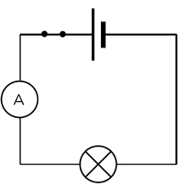 |  |  | 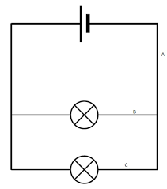
10 | Cell | Gives the electrons energy. 2 cells make a battery.
11 | Diode | A component that makes the current flow in one direction only.
12 | Fuse | The fuse breaks the circuit if a fault in an appliance causes too much current to flow.
13 | Component | Parts of a circuit. E.g bulb, switch, ammeter.
14 | Bulb | Gives out light energy.
15 | Wires | Current flows through the wire because they contain electrons, that move to make a current. | Diagram 1: Series circuit |  |  | Diagram 2: Parallel Circuit

