KS3 Forces
Definitions
1 | Force | A force can change the speed, direction or shape of an object. | 16 | Terminal velocity | Terminal velocity happens at the moment in time that the force, because of gravity, called weight, is the same as the opposite force of air resistance or friction.
2 | Contact Force | A force that acts by direct contact e.g. friction, air resistance. | 17 | Compression | Being squashed.
3 | Non- contact force | A force that does not need direct contact to act e.g. gravity, magnetism | 18 | Deformation | Changing shape as a result of forces being applied.
4 | Gravity | A force that attracts objects towards each other. | Investigation skills
5 | Air resistance | A force that is caused by the frictional forces of the air hitting an object. | 19 | Directly proportional | As one amount increase, so does the other, at equal rates. On a graph, this will pass through the origin.
6 | Magnetism | A force is exerted on a magnetic material brought into a magnetic field. | 20 | Gradient | The steepness of a line. The gradient of a line of best fir can be calculated.
7 | Up thrust | An upward force exerted by a liquid or gas on an objecting floating in it. | 21 | Tangent | A straight line that touches a curve at a point.
8 | Mass | The mass of an object is the amount of matter or 'stuff' it contains. Measure in grams (g) or kilograms (kg). | 22 | Hook’s law | The extension of an elastic object, such as a spring, is described by Hooke's law; the force applied to the spring is directly proportional to the extension of the spring.
9 | Weight | The weight of an object is how hard gravity pulls down on an object. | 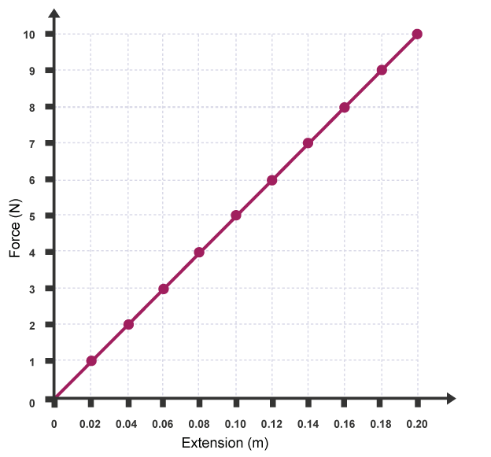 |  |  | Gradient = change in y  change in x  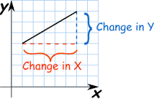
10 | Newtons | The unit of force (N).
11 | Newton- meter | The equipment used to measure the force acting on an object.
12 | Friction | Objects, which rub against each other, have friction. Friction works against motion.
13 | Elastic | An object that will return to its original shape when the force is removed.
14 | Plastic | A material that does not return to its original shape when the force is removed.
15 | Pressure | Pressure is the force per unit area. | Diagram 1: Hook’s Law |  |  | Diagram 2: How to calculate a gradient

