Sound and light engineer
Definitions |  |  | Primary colours of light
1 | Reflection | Waves, including sound and light, can be reflected at the boundary between two different materials. | 16 | Red | Red + green = yellow
2 | Refraction | Light changes speed and direction when it passes through a different density material | 17 | Blue | Blue + red = magenta
3 | Normal | A line at right angles to a surface. | 18 | Green | Green + blue = cyan
4 | Angle of incidence | The angle between the normal and incident ray | Investigation skills
5 | Angle of reflection | The angle between the normal and reflected ray. | 19 | Describe | Recall the facts, evets or process in an accurate way.
6 | Spectrum | A band of colours, as seen in a rainbow, produced by separation of light, based on its wavelength. | 20 | Explain | State the reasons for something happening. Use the format:…..because…..therefore
7 | Pupil | The opening in the iris, through which light passes. | 21 | Plot | Mark on a graph using the data given
8 | Iris | The coloured part of the eye, controls how much light passes through the pupil. | 22 | Evaluate | Give the for and against sides of the argument.
9 | Cornea | The protective layer on the eye which also refracts the light. | 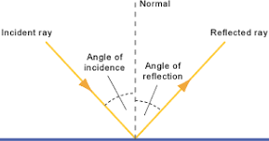 |  |  | 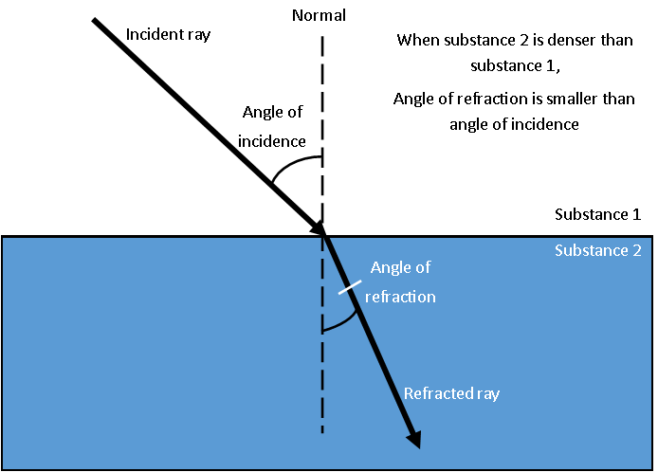
10 | Rods | Light sensitive cells which detect light intensity.
11 | Cones | Light sensitive cells which detect colour.
12 | Virtual image | A virtual image cannot be projected on a screen
13 | Real image | The point at which rays of light focus to form an image.
14 | Prism | A prism is a transparent optical element with flat, polished surfaces that refract light.
15 | Shadow |  | Diagram 1: Reflection |  |  | Diagram 2: Refraction

Definitions
1 | Amplitude | The height of a wave (see fig 2) | 16 | Ultrasound | Sounds made with a frequency above 20,000Hz
2 | Frequency | The number of waves per second | 17 | Infrasound | Sounds made with a frequency below 20 Hz
3 | Wavelength | The length of a wave – one complete cycle | 18 | Dissipated | Energy that is lost to the environment
4 | Pitch | The higher the frequency, the higher the pitch
5 | Longitudinal | The vibrations are parallel to the direction of wave travel. | 19 | Compression | Regions of high pressure due to particles being close together, in a longitudinal wave (see fig 2)
6 | Transverse | The vibrations are at right angles to the direction of wave travel. | 20 | Rarefaction | Regions of low pressure due to the particles being spread further apart (see fig 2)
7 | Wave | Waves transfer energy without transferring matter | 21 | Speed equation | Speed = distance / time
8 | Vacuum | An area without any particles e.g Space | 22 | Oscilloscope | A used to display and analyse the waveform of electronic signals.
9 | Cochlea | Filled with fluid, receives sound in the form of vibrations | 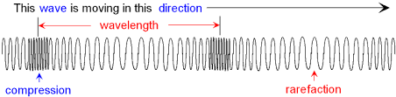 |  |  | 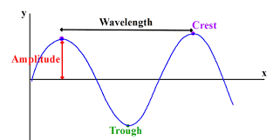
10 | Ear drum | Thin layer of skin that vibrates
11 | Auditory nerve | Converts the vibrations in the ear into electrical impulses to send to the brain.
12 | Seismic | Waves generated by an earthquake
13 | Hertz | The unit of frequency. 5 waves per second will have a frequency of 5Hz
14 | Decibels | The unit for measuring the volume of a sound.
15 | Superposition | When waves meet, they add or cancel out. | Fig 1: Longitudinal wave |  |  | Fig 2: Transverse wave

