Developing the skills for AQA English Language Paper 1

English Language Skills Booklet

Question 1: Information Retrieval
What skills do we need for this question?
• Identify and interpret explicit and implicit information and ideas
[To pick out information that is stated in the text as well as information that is implied}
• Select and synthesise evidence from different texts.
[To choose and combine information from different texts]

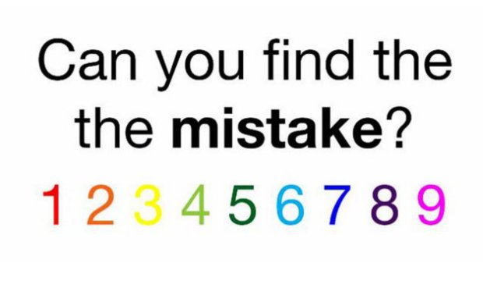
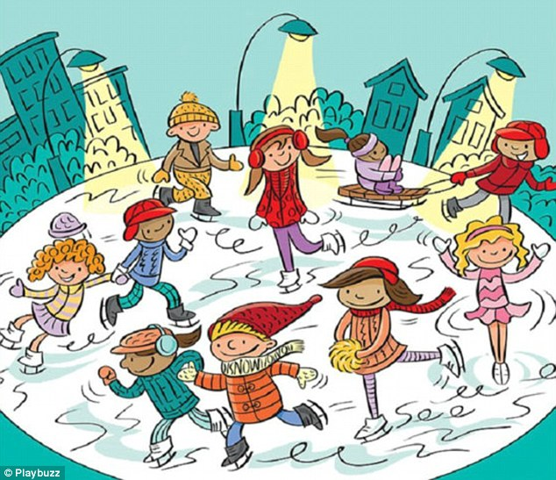
Step 1: Look at the images below. Can you find what the mistake is in this image?

Picture 2
Can you find the 6 hidden words in this image?

Question 1 is all about being able to pick out information from a text. You need to use your detective skills for this question.
Practice Section
Example question (Text taken from The Hobbit). Read the passage below.
List four things from the text about Gollum.
Deep down here by the dark water lived old Gollum, a small slimy creature. I don't know where he came from, nor who or what he was. He was Gollum - as dark as darkness, except for two big round pale eyes in his thin face. He had a little boat, and he rowed about quite quietly on the lake; for lake it was, wide and deep and deadly cold. He paddled it with large feet dangling over the side, but never a ripple did he make. Not he. He was looking out of his pale lamp-like eyes for blind fish, which he grabbed with his long fingers as quick as thinking. He liked meat too. Goblin he thought good, when he could get it; but he took care they never found him out. He just throttled them from behind, if they ever came down alone anywhere near the edge of the water, while he was prowling about. They very seldom did, for they had a feeling that something unpleasant was lurking down there, down at the very roots of the mountain. They had come on the lake, when they were tunnelling down long ago, and they found they could go no further; so there their road ended in that direction, and there was no reason to go that way-unless the Great Goblin sent them. Sometimes he took a fancy for fish from the lake, and sometimes neither goblin nor fish came back.
1.
2.
3.
4.
So, what could you have chosen?
Deep down here by the dark water lived old Gollum, a small slimy creature. I don't know where he came from, nor who or what he was. He was Gollum - as dark as darkness, except for two big round pale eyes in his thin face. He had a little boat, and he rowed about quite quietly on the lake; for lake it was, wide and deep and deadly cold. He paddled it with large feet dangling over the side, but never a ripple did he make. Not he. He was looking out of his pale lamp-like eyes for blind fish, which he grabbed with his long fingers as quick as thinking. He liked meat too. Goblin he thought good, when he could get it; but he took care they never found him out. He just throttled them from behind, if they ever came down alone anywhere near the edge of the water, while he was prowling about. They very seldom did, for they had a feeling that something unpleasant was lurking down there, down at the very roots of the mountain. They had come on the lake, when they were tunnelling down long ago, and they found they could go no further; so there their road ended in that direction, and there was no reason to go that way-unless the Great Goblin sent them. Sometimes he took a fancy for fish from the lake, and sometimes neither goblin nor fish came back.

Your turn:
For this question, you do not have to put the information in your own words. You can copy directly from the text but remember only copy out the relevant part e.g.
- He was a small, slimy creature.
- He had a thin face…
Now, practice with these texts below.
Extract from Harry Potter and the Goblet of Fire
The villagers of Little Hangleton still called it “the Riddle House,” even though it had been many years since the Riddle family had lived there. It stood on a hill overlooking the village, some of its windows boarded, tiles missing from its roof, and ivy spreading unchecked over its face. Once a fine-looking manor, and easily the largest and grandest building for miles around, the Riddle House was now damp, derelict, and unoccupied. The Little Hangletons all agreed that the old house was “creepy.”
Half a century ago, something strange and horrible had happened there, something that the older inhabitants of the village still liked to discuss when topics for gossip were scarce. The story had been picked over so many times, and had been embroidered in so many places, that nobody was quite sure what the truth was anymore.
List four things from the text about ‘the Riddle House.’
1.
2.
3.
4.

Extract from Lord of the Flies
The shore was fledged with palm trees. These stood or leaned or reclined against the light and their green feathers were a hundred feet up in the air. The ground beneath them was a bank covered with coarse grass, torn everywhere by the upheavals of fallen trees, scattered with decaying coconuts and palm saplings. Behind this was the darkness of the forest proper and the open space of the scar. Ralph stood, one hand against a grey trunk, and screwed up his eyes against the shimmering water. Out there, perhaps a mile away, the white surf flinked on a coral reef, and beyond that the open sea was dark blue. Within the irregular arc of coral, the lagoon was still as a mountain lake--blue of all shades and shadowy green and purple. The beach between the palm terrace and the water was a thin stick, endless apparently, for to Ralph's left the perspectives of palm and beach and water drew to a point at infinity; and always, almost visible, was the heat.
List four things from the text about the setting.
1.
2.
3.
4.

Question 2: Language and Structure
Question 2 is all about exploring how writers use language and structure to achieve certain effects and influence readers to feel a certain way.
What do we mean by language?
Language can mean the specific words (adjectives, verbs, nouns, adverbs etc.) used by the writer that help to bring the text to life. For example, look at the paragraphs below, which words would you highlight as being interesting?
Yes, the sky was now a devastating, home-cooked red. The small German town had been flung apart one more time. Snowflakes of ash fell so lovely you were tempted to stretch out your tongue to catch them, taste them. Only, they would have scorched your lips. They would have cooked your mouth.
Think:
Take for example the verb ‘scorched’ why is this more effective than ‘burned’?
Language can also refer to specific figurative devices used by the writer (similes, metaphors, personification, sensory language, pathetic fallacy etc.) to create an image in the reader’s head.
Task:
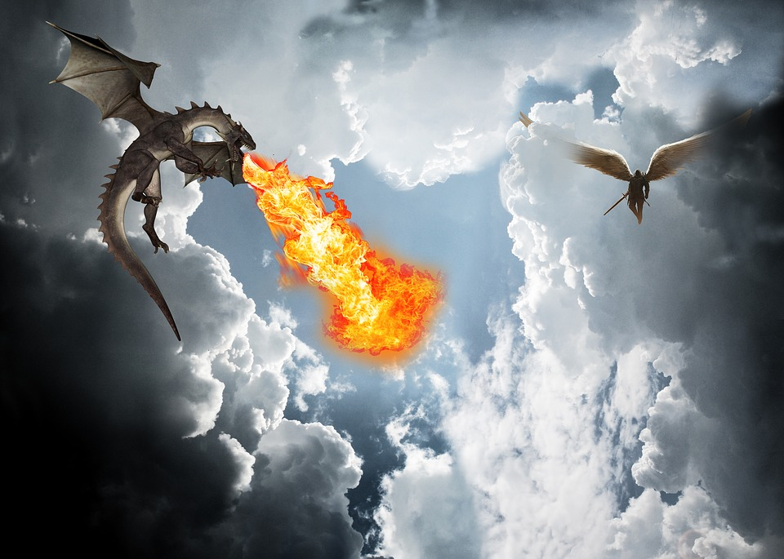
Look at this image and the two descriptions that follow. Which one is more effective at bringing the image to life?

- The tall dragon looked down at the people below him, who looked as small as ants. His nostrils blew out black smoke and his hot breath could be felt for miles around. His wings were black with blue swirls that filled the night sky. Another dragon could be seen in the distance and he also looked scary.

- Raising his magnificent head towards the sapphire coloured sky, the dragon peered down at the miniscule humans below, who were huddled together like bears trying to keep warm during the icy winter months. His scales were an intricate pattern of swirls and twirls, as if a spider had danced her merry way weaving her delicate webbing all over him.
Task:
Explain which description you preferred and why. Focus on picking out some of the words or figurative devices used by the writer and try to include them in your answer.

What do we mean by structure?
Structure refers to how the text is put together through the types of sentences used and the punctuation within those sentences.
Task
Have a look at this extract from The Hunger Games. What makes this an effective paragraph in terms of the structure of the text?
Sixty seconds. That's how long we're required to stand on our metal circles before the sound of a gong releases us. Step off before the minute is up, and land mines blow your legs off. Sixty seconds to take in the ring of tributes all equidistant from the Cornucopia, a giant golden horn shaped like a cone with a curved tail, the mouth of which is at least twenty feet high, spilling over with the things that will give us life here in the arena. Food, containers of water, weapons, medicine, garments, fire starters. Strewn around the Cornucopia are other supplies, their value decreasing the farther they are from the horn. For instance, only a few steps from my feet lies a three-foot square of plastic. Certainly, it could be of some use in a downpour. But there in the mouth, I can see a tent pack that would protect from almost any sort of weather. If I had the guts to go in and fight for it against the other twenty-three tributes. Which I have been instructed not to do.

Now imagine you had the following question. How does the writer use language and structure here to build tension?

Sixty seconds. That's how long we're required to stand on our metal circles before the sound of a gong releases us. Step off before the minute is up, and land mines blow your legs off. Sixty seconds to take in the ring of tributes all equidistant from the Cornucopia, a giant golden horn shaped like a cone with a curved tail, the mouth of which is at least twenty feet high, spilling over with the things that will give us life here in the arena. Food, containers of water, weapons, medicine, garments, fire starters. Strewn around the Cornucopia are other supplies, their value decreasing the farther they are from the horn. For instance, only a few steps from my feet lies a three-foot square of plastic. Certainly, it could be of some use in a downpour. But there in the mouth, I can see a tent pack that would protect from almost any sort of weather. If I had the guts to go in and fight for it against the other twenty-three tributes. Which I have been instructed not to do.
- The opening short sentence shows how little time the protagonist has to make her decision. It is repeated again later on to emphasise how time is running out.
- ‘Land mines blow your legs off’ shows how perilous the situation is. The language is blunt and direct to show the consequences of making the wrong choice.
- ‘…spilling over…’ shows how there are an abundance of items to choose from which makes the decision what to choose more difficult
- ‘If I had the guts…’ first person narrative viewpoint makes us empathise with the protagonist as we can feel how important making the right decision is.
- The final sentence ‘Which I have been instructed not to do’ shows how someone else may be controlling the protagonist’s actions showing she has another barrier to overcome.
Your turn:
How does the writer use language and structure here to describe the excitement of Willy Wonka?
You could include the writer’s choice of:
• words and phrases • language features and techniques • sentence forms.
Extract from Charlie and the Chocolate Factory
Charlie Bucket stared around the gigantic room in which he now found himself. The place was like a witch’s kitchen! All about him black metal pots were boiling and bubbling on huge stoves, and kettles were hissing and pans were sizzling, and strange iron machines were clanking and spluttering, and there were pipes running all over the ceiling and walls, and the whole place was filled with smoke and steam and delicious rich smells. Mr Wonka himself had suddenly become even more excited than usual, and anyone could see that this was the room he loved best of all. He was hopping about among the saucepans and the machines like a child among his Christmas presents, not knowing which thing to look at first. He lifted the lid from a huge pot and took a sniff; then he rushed over and dipped a finger into a barrel of sticky yellow stuff and had a taste; then he skipped across to one of the machines and turned half a dozen knobs this way and that; then he peered anxiously through the glass door of a gigantic oven, rubbing his hands and cackling with delight at what he saw inside. Then he ran over to another machine, a small shiny affair that kept going phut-phut-phut-phut-phut, and every time it went phut, a large green marble dropped out of it into a basket on the floor.

How does the writer use language and structure here to describe the character of Magwitch?
You could include the writer’s choice of:
• words and phrases • language features and techniques • sentence forms.
Extract from Great Expectations
"Hold your noise!" cried a terrible voice, as a man started up from among the graves at the side of the church porch. "Keep still, you little devil, or I'll cut your throat!"
A fearful man, all in coarse grey, with a great iron on his leg. A man with no hat, and with broken shoes, and with an old rag tied round his head. A man who had been soaked in water, and smothered in mud, and lamed by stones, and cut by flints, and stung by nettles, and torn by briars; who limped, and shivered, and glared and growled; and whose teeth chattered in his head as he seized me by the chin.

Question 3: Structure
What do we mean by Structure?
Structural features can be: at a whole text level, e.g. beginnings / endings / perspective shifts; at a paragraph level, e.g. Topic change / aspects of cohesion; and at a sentence level when judged to contribute to whole structure.
It can also mean how the text is organised e.g.
- Use of flashbacks
- The ordering of ideas
- Use of dialogue
- Withholding information until later on to shock the reader
- Use of repetition
- Listing
- Whose point of view is it written from?
Words we associate with structure
Character Setting Plot Time Atmosphere Contrast Foreshadow
Repetition Short sentence Complex sentence Theme Protagonist Antagonist
Connectives Chronologically Begins Ends Climax Anti-Climax List

Your Turn
Have a look at this passage from Cirque Du Freak.
- Begin by reading the passage through and underlining anything that interests you as the reader or makes you want to find out more about the story.
- Now write a short summary of what happens in the extract – look at the beginning, middle and end.
- Now think about what information does the writer want you to take away from this passage.
- Now using the words from above, how has the writer tried to interest you as the reader?
Cirque du Freak
I’VE ALWAYS been fascinated by spiders. I used to collect them when I was younger. I’d spend hours rooting through the dusty old shed at the bottom of our garden, hunting the cobwebs for lurking eight-legged predators. When I found one, I’d bring it in and let it loose in my bedroom.
It used to drive my mum mad!
Usually, the spider would slip away after no more than a day or two, never to be seen again, but sometimes they hung around longer. I had one who made a cobweb above my bed and stood sentry for almost a month. Going to sleep, I used to imagine the spider creeping down, crawling into my mouth, sliding down my throat and laying loads of eggs in my belly. The baby spiders would hatch after a while and eat me alive, from the inside out.
I loved being scared when I was little.
When I was nine, my mum and dad gave me a small tarantula. It wasn’t poisonous or very big, but it was the greatest gift I’d ever received. I played with that spider almost every waking hour of the day. Gave it all sorts of treats: flies and cockroaches and tiny worms. Spoilt it rotten.
Then, one day, I did something stupid. I’d been watching a cartoon in which one of the characters was sucked up by a vacuum cleaner. No harm came to him. He squeezed out of the bag, dusty and dirty and mad as hell. It was very funny.
So funny, I tried it myself. With the tarantula.
Needless to say, things didn’t happen quite like they did in the cartoon. The spider was ripped to pieces. I cried a lot, but it was too late for tears. My pet was dead, it was my fault, and there was nothing I could do about it.
My parents nearly hollered the roof down when they found out what I’d done - the tarantula had cost quite a bit of money. They said I was an irresponsible fool, and from that day on they never again let me have a pet, not even an ordinary garden spider.
I started with that tale from the past for two reasons. One will become obvious as this book unfolds. The other reason is:
This is a true story.
I don’t expect you to believe me - I wouldn’t believe it myself if I hadn’t lived it - but it is.
Everything I describe in this book happened, just as I tell it.
The thing about real life is, when you do something stupid, it normally costs you. In books, the heroes can make as many mistakes as they like. It doesn’t matter what they do, because everything comes good at the end. They’ll beat the bad guys and put things right and everything ends up hunky-dory.
In real life, vacuum cleaners kill spiders. If you cross a busy road without looking, you get whacked by a car. If you fall out of a tree, you break some bones.
Real life’s nasty. It’s cruel. It doesn’t care about heroes and happy endings and the way things should be. In real life, bad things happen. People die. Fights are lost. Evil often wins.
I just wanted to make that clear before I began.
One more thing: my name isn’t really Darren Shan. Everything’s true in this book, except for names. I’ve had to change them because... well, by the time you get to the end, you’ll understand.
I haven’t used any real names, not mine, my sister’s, my friends or teachers. Nobody’s. I’m not even going to tell you the name of my town or country. I daren’t.
Anyway, that’s enough of an introduction. If you’re ready, let’s begin. If this was a made-up story, it would begin at night, with a storm blowing and owls hooting and rattling noises under the bed. But this is a real story, so I have to begin where it really started.
It started in a toilet

Question 4: Evaluation
AO4 Evaluate texts critically and support this with appropriate textual references
This question requires you to form an opinion and then use evidence to justify your point of view. There will be a statement that you will most likely agree with.
This means that you will be asked to consider what the writer intended to achieve in the selected passage. Then you will need to say how far you feel that he or she achieved it. You must support your views with relevant quotations.

Extract from Miss Peregrine’s School for Peculiar Children
My grandfather lay face down in a bed of creeper, his legs sprawled out and one arm twisted beneath him as if he’d fallen from a great height. I thought surely, he was dead. His undershirt was soaked with blood, his pants were torn, and one shoe was missing. For a long moment I just stared, the beam of my flashlight shivering across his body. When I could breathe again I said his name, but he didn’t move.
I sank to my knees and pressed the flat of my hand against his back. The blood that soaked through was still warm. I could feel him breathing ever so shallowly.
A moment later Ricky crashed out of the underbrush. He saw the old man limp in my arms and fell back a step. “Oh man. Oh Jesus. Oh Jesus,” he said, rubbing his face with his hands, and as he babbled about finding a pulse and calling the cops and did you see anything in the woods, the strangest feeling came over me. I let go of my grandfather’s body and stood up, every nerve ending tingling with an instinct I didn’t know I had. There was something in the woods, all right—I could feel it.
There was no moon and no movement in the underbrush but our own, and yet somehow, I knew just when to raise my flashlight and just where to aim it, and for an instant in that narrow cut of light I saw a face that seemed to have been transplanted directly from the nightmares of my childhood. It stared back with eyes that swam in dark liquid, furrowed trenches of carbon-black flesh loose on its hunched frame, its mouth hinged open grotesquely so that a mass of long eel-like tongues could wriggle out. I shouted something and then it twisted and was gone, shaking the brush and drawing Ricky’s attention. He raised his .22 and fired,pap-pap-pap-pap, saying, “What was that? What the hell was that?” But he hadn’t seen it and I couldn’t speak to tell him, frozen in place as I was, my dying flashlight flickering over the blank woods. And then I must’ve blacked out because he was saying Jacob, Jake, hey Ed are you okay or what, and that’s the last thing I remember.

Practice Question
A student, reading this part of the text said:
‘The writer makes the death of Jacob’s grandfather dramatic for the reader. It is as if you are inside the forest with them.
To what extent do you agree?
In your response, you should:
- Write about your own impressions of the shark as described in the passage
- Evaluate how the writer has created these impressions
- Support your opinions with quotations from the text

Task:
- How do you think the writer wants you to feel at this point in the novel?
- Can you find any evidence to prove this?
- What words/ phrases has the writer used to make you feel like you are present in the scene?
Now, complete the following:
- Establish what the writer’s intentions are. Write one or two sentences to sum up what the writer’s intentions are in relation to the statement.
- Now look to see if the writer has used any of the following to bring the text to life for the reader:
- Description of character (characterisation)
- Character actions and dialogue
- Setting
- Atmosphere (mood)
- Events
- Now answer the question using the sentence starters to help you.

You could use some of these sentences to start you off.
- I agree/disagree because…
- In this section of the text, the viewpoint changes…
- To some extent I agree…
- I strongly agree that…
- However, some people may disagree that ‘…………………’ because…
- This is supported by the quote “…
- The use of (insert device or word/ phrase) implies the idea in the statement because…
- The writer’s choice of the verb/ noun/ adjective ‘…..’….
- The effect the writer wants to create is…
- The writer’s method is effective because…
- The reader may feel…
- Personally, I think that………. as………..

Exam Practice:
Extract from The Secret Garden
This extract is from the opening of a novel by. In this section Mary Lennox is angry that her servant has not arrived to get her ready.
1  10  21 | When Mary Lennox was sent to Misselthwaite Manor to live with her uncle everybody said she was the most disagreeable-looking child ever seen. It was true, too. She had a little thin face and a little thin body, thin light hair and a sour expression. Her hair was yellow, and her face was yellow because she had been born in India and had always been ill in one way or another. Her father had held a position under the English Government and had always been busy and ill himself, and her mother had been a great beauty who cared only to go to parties and amuse herself with gay people. She had not wanted a little girl at all, and when Mary was born she handed her over to the care of an Ayah, who was made to understand that if she wished to please the Mem Sahib she must keep the child out of sight as much as possible. So when she was a sickly, fretful, ugly little baby she was kept out of the way, and when she became a sickly, fretful, toddling thing she was kept out of the way also. She never remembered seeing familiarly anything but the dark faces of her Ayah and the other native servants, and as they always obeyed her and gave her her own way in everything, because the Mem Sahib would be angry if she was disturbed by her crying, by the time she was six years old she was as tyrannical and selfish a little pig as ever lived. The young English governess who came to teach her to read and write disliked her so much that she gave up her place in three months, and when other governesses came to try to fill it they always went away in a shorter time than the first one. So if Mary had not chosen to really want to know how to read books she would never have learned her letters at all.  One frightfully hot morning, when she was about nine years old, she awakened feeling very cross, and she became crosser still when she saw that the servant who stood by her bedside was not her Ayah.  “Why did you come?” she said to the strange woman. “I will not let you stay. Send my Ayah to me.”  The woman looked frightened, but she only stammered that the Ayah could not come and when Mary threw herself into a passion and beat and kicked her, she looked only more frightened and repeated that it was not possible for the Ayah to come to Missie Sahib.  There was something mysterious in the air that morning. Nothing was done in its regular order and several of the native servants seemed missing, while those whom Mary saw slunk or hurried about with ashy and scared faces. But no one would tell her anything and her Ayah did not come. She was actually left alone as the morning went on, and at last she wandered out into the garden and began to play by herself under a tree near the veranda. She pretended that she was making a flower-bed, and she stuck big scarlet hibiscus blossoms into little heaps of earth, all the time growing more and more angry and muttering to herself the things she would say and the names she would call Saidie when she returned.

Q1. Read again the first part of the Source from lines 1 to 10.
List four things from this part of the text we learn about Mary Lennox.
1.
2
3.
4.
[4 marks]

Q2.
So, when she was a sickly, fretful, ugly little baby she was kept out of the way, and when she became a sickly, fretful, toddling thing she was kept out of the way also. She never remembered seeing familiarly anything but the dark faces of her Ayah and the other native servants, and as they always obeyed her and gave her her own way in everything, because the Mem Sahib would be angry if she was disturbed by her crying, by the time she was six years old she was as tyrannical and selfish a little pig as ever lived. The young English governess who came to teach her to read and write disliked her so much that she gave up her place in three months, and when other governesses came to try to fill it they always went away in a shorter time than the first one. So, if Mary had not chosen to really want to know how to read books she would never have learned her letters at all.
How does the writer use language here to describe the character of Mary?
You could include the writer’s choice of:
- words and phrases
- language features and techniques
- sentence forms. [8 marks]
Q3. You now need to think about the whole of the Source.
This text is from the opening of a novel.
How has the writer structured the text to interest you as a reader?
You could write about:
- what the writer focuses your attention on at the beginning
- how and why the writer changes this focus as the Source develops
- any other structural features that interest you. [8 marks]

Q4. Focus this part of your answer on the second part of the Source from line 21 to the end.
A student, having read this section of the text said: “The writer makes the character of Mary sound unpleasant to the reader. It is as if you are meant to dislike her from the start.”
To what extent do you agree?
In your response, you could:
- write about your own impressions of the characters
- evaluate how the writer has created these impressions
- support your opinions with references to the text. [20 marks]

Extract from Tuck Everlasting
This extract is from the opening of a novel by Natalie Babbitt. In this section Winnie Foster has decided that she is going to run away from home.
1  5  10  15  20  25  30  35  40  45  50 | At noon of that same day in the first week of August, Winnie Foster sat on the bristly grass just inside the fence and said to the large toad who was squatting a few yards away across the road, "I will, though. You'll see. Maybe even first thing tomorrow, while everyone's still asleep."  It was hard to know whether the toad was listening or not. Certainly, Winnie had given it good reason to ignore her. She had come out to the fence, very cross, very near the boiling point on a day that was itself near to boiling, and had noticed the toad at once. It was the only living thing in sight except for a stationary cloud of hysterical gnats suspended in the heat above the road. Winnie had found some pebbles at the base of the fence and, for lack of any other way to show how she felt, had flung one at the toad. It missed altogether, as she'd fully intended it should, but she made a game of it anyway, tossing pebbles at such an angle that they passed through the gnat cloud on their way to the toad. The gnats were too frantic to notice these intrusions, however, and since every pebble missed its final mark, the toad continued to squat and grimace without so much as a twitch. Possibly it felt resentful. Or perhaps it was only asleep. In either case, it gave her not a glance when at last she ran out of pebbles and sat down to tell it her troubles.  "Look here, toad," she said, thrusting her arms through the bars of the fence and plucking at the weeds on the other side. "I don't think I can stand it much longer."  At this moment, a window at the front of the cottage was flung open and a thin voice—her grandmother's—piped, "Winifred! Don't sit on that dirty grass. You'll stain your boots and stockings."  And another, firmer voice—her mother's—added, "Come in now, Winnie. Right away. You'll get heat stroke out there on a day like this. And your lunch is ready."  "See?" said Winnie to the toad. "That's just what I mean. It's like that every minute. If I had a sister or a brother, there'd be someone else for them to watch. But, as it is, there's only me. I'm tired of being looked at all the time. I want to be by myself for a change." She leaned her forehead against the bars and after a short silence went on in a thoughtful tone. "I'm not exactly sure what I'd do, you know, but something interesting—something that's all mine. Something that would make some kind of difference in the world. It'd be nice to have a new name, to start with, one that's not all worn out from being called so much. And I might even decide to have a pet. Maybe a big old toad, like you, that I could keep in a nice cage with lots of grass, and . . ."  At this the toad stirred and blinked. It gave a heave of muscles and plopped its heavy mudball of a body a few inches farther away from her.  "I suppose you're right," said Winnie. "Then you'd be just the way I am, now. Why should you have to be cooped up in a cage, too? It'd be better if I could be like you, out in the open and making up my own mind. Do you know they've hardly ever let me out of this yard all by myself? I'll never be able to do anything important if I stay in here like this. I expect I'd better run away." She paused and peered anxiously at the toad to see how it would receive this staggering idea, but it showed no signs of interest. "You think I wouldn't dare, don't you?" she said accusingly. "I will, though. You'll see. Maybe even first thing in the morning, while everyone's still asleep."  "Winnie!" came the firm voice from the window.  "All right! I'm coming!" she cried, exasperated, and then added quickly, "I mean, I'll be right there, Mama."  She stood up, brushing at her legs where bits of itchy grass clung to her stockings.  The toad, as if it saw that their interview was over, stirred again, bunched up, and bounced itself clumsily off toward the wood. Winnie watched it go. "Hop away, toad," she called after it. "You'll see. Just wait till morning."

Q1. Read again the first part of the Source from lines 1 to 10.
List four things from this part of the text we learn about the setting.
1.
2
3.
4.
[4 marks]

Q2.
It was hard to know whether the toad was listening or not. Certainly, Winnie had given it good reason to ignore her. She had come out to the fence, very cross, very near the boiling point on a day that was itself near to boiling, and had noticed the toad at once. It was the only living thing in sight except for a stationary cloud of hysterical gnats suspended in the heat above the road. Winnie had found some pebbles at the base of the fence and, for lack of any other way to show how she felt, had flung one at the toad. It missed altogether, as she'd fully intended it should, but she made a game of it anyway, tossing pebbles at such an angle that they passed through the gnat cloud on their way to the toad. The gnats were too frantic to notice these intrusions, however, and since every pebble missed its final mark, the toad continued to squat and grimace without so much as a twitch. Possibly it felt resentful. Or perhaps it was only asleep. In either case, it gave her not a glance when at last she ran out of pebbles and sat down to tell it her troubles.
How does the writer use language here to describe the effect of the heat on Mary?
You could include the writer’s choice of:
- words and phrases
- language features and techniques
- sentence forms. [8 marks]
Q3. You now need to think about the whole of the Source.
This text is from the opening of a novel.
How has the writer structured the text to interest you as a reader?
You could write about:
- what the writer focuses your attention on at the beginning
- how and why the writer changes this focus as the Source develops
- any other structural features that interest you. [8 marks]

Q4. Focus this part of your answer on the second part of the Source from line 25 to the end.
A student, having read this section of the text said: “The writer makes the character of Winnie sound trapped to the reader. It is as if you are meant to want her to run away.”
To what extent do you agree?
In your response, you could:
- write about your own impressions of the characters
- evaluate how the writer has created these impressions
- support your opinions with references to the text. [20 marks]

Section B: Writing
For this part of the exam, you will be tested on your ability to write for a particular audience and purpose and also how accurate you can write.
AO5 Content and Organisation
Communicate clearly, effectively and imaginatively, selecting and adapting tone, style and register for different forms, purposes and audiences.
Organise information and ideas, using structural and grammatical features to support coherence and cohesion of texts.
AO6 Technical Accuracy
Candidates must use a range of vocabulary and sentence structures for clarity, purpose and effect, with accurate spelling and punctuation.

You could be asked to:
- Describe a picture
- Write the opening to a story
- Write the ending to a story
- Write a story using a given title

Key things to remember:
- Plan first
- Leave time to check your work at the end
- Use ambitious vocabulary
- Think about sentence openers and types of sentences
- Use a variety of punctuation
- Use figurative devices

Your Turn:
Practice planning for each of the following tasks:
- Write the opening to a story with the title ‘The Key’

- Write a story about a character who tells a lie.

- Write a story in which this character features.

You could use a planning grid like this to help:

Vocabulary | Connectives | Openers | Punctuation

