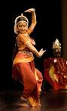
Bollywood
Bollywood dance moves are now a familiar sight on Western TV and cinema screens. But what is the symbolism of the gestures, footwork and costumes drawn from classical Indian dance styles?
Bollywood dance is easy on the eye. Dramatic facial expressions and cinematic pizzazz means any viewer can follow the story.
But beneath the fizz is a series of historic symbols and traditions, which originate in India's numerous traditional dance forms.
Classical dance forms such as Bharatnatyam and Kathak, and folk dances such as Bhangra, each have their own unique styles, but they often share signs and meanings that are combined to create modern Bollywood dances.
Hand movements
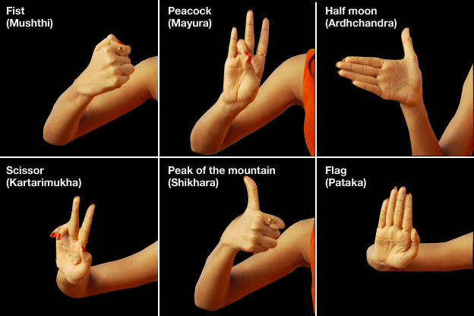
Creative Task
Research further on ‘Bollywood’ dance. View some clips on youtube. Have a go at creating a short piece of dance, incorporating at least 3 of the hand gestures above. If you are able to do so, film your performance. Evaluate: WWW & EBI….what did you do well? What have you learnt? What could you improve?

