Purpose and content of mind maps

# Activity 2.1 – Warm up questions

Answer the questions below in full sentences. Remember – there are marks awarded for the ‘quality of written communication’ in the exam. This means they will be looking at sentence structure, spelling, grammar and punctuation.

1. What is a mind map?

_________________________________________________________________________________________________________________________________________________________________________________________________________________________________

1. Why do we use mind maps?
2. _______________________________________________________________________
3. _______________________________________________________________________
4. _______________________________________________________________________
5. _______________________________________________________________________
6. _______________________________________________________________________
7. Label the parts of the mind map below
8. ______________________
9. ______________________
10. ______________________

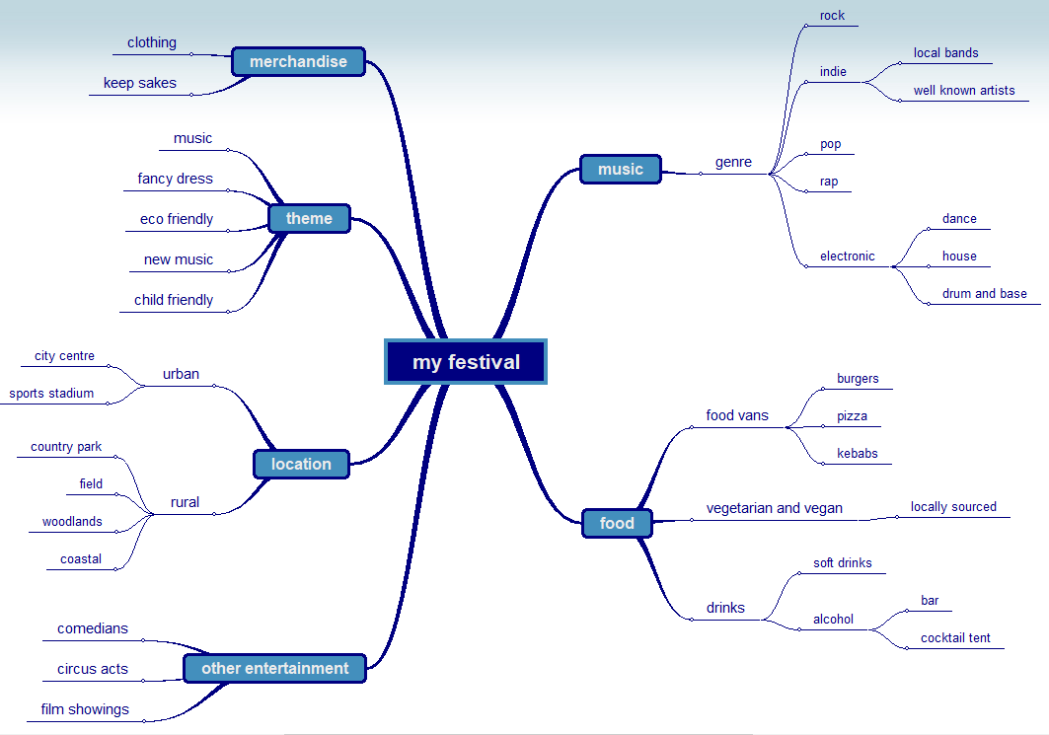

B

C

A

# Activity 2.2 – Mark the answer

Progressive Park is a theme park which has a new ride opening next summer. The new rollercoaster ride will allow riders to wear virtual reality goggles as they speed through different parts of the United Kingdom (UK) at various times in its history.

Progressive Park want to produce a website to advertise the new ride

1. Create a mind map that can be used by the production team to help plan the development of the website.

[7]

|  |
| --- |
| **Level 3: 6–7 Marks** Clear structure with logical connections. Content is relevant to context and the development of a website for the ride. Detail is clear and understandable. Subject specific terminology will be used. |
| **Level 2: 4–5 Marks.** Structure of diagram is clear but may not be totally logical. Content not fully relevant to context and the development of a website for the ride. Subject specific terminology may be occasionally used. |
| **Level 1: 1–3 Marks** Diagram has little structure. Content may not be appropriate Links may not be totally logical. Little subject specific terminology will be used |