Year 7,8 & 9 Core PE
Day | Activity
Monday | WORD OF THE DAY  Each week you must research the word of the week – write the definition down. You can create a poster, write an article or poem using the word in the correct context. You can spell the key word using members of your family for each letter or using pebbles / shells or petals (remember to ask first) always wash your hands.  30/03/20 – Sportsmanship 06/04/20 – Etiquette  13/04/20 – Gamesmanship 20/04/20 – Sponsorship  27/04/20 – Leadership 04/05/20 – Volunteer  11/05/20 – Provision 18/05 /20 –Spectatorship
Tuesday | PRACTICAL  - Mr Sutton’s workout with Moose on Westleigh PE twitter (upload your video or it didn’t happen)  - Joe Wicks 9am workout  - Dance lesson with Oti Mabuse – on Facebook every day at 11.30am
Wednesday | CHALLENGE DAY  - 2.  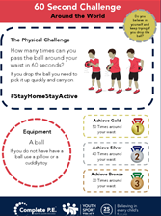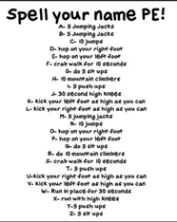  3 4.  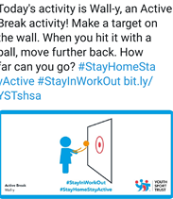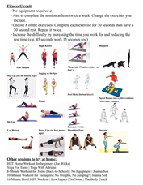  5. 6.  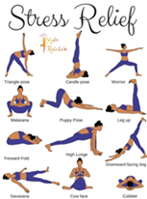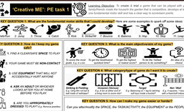  7. 8.
Thursday | PRACTICAL  - Joe Wicks 9am workout  - Mr Sutton’s workout with Moose on Westleigh PE twitter (upload your video or it didn’t happen)  - Dance with Oti Mabuse – on Facebook every day at 11.30am
Friday | RECALL  What have you remembered from this week?  Either make up your own mini test or ask a member of your family to test you on the word of the week [each week there is a new word to remember]

