

**Name:**

**Teacher:**eacher..

|  |
| --- |
| @WHSTeamEnglish |

|  |  |
| --- | --- |
|  | Jekyll & Hyde |



|  |  |
| --- | --- |
| **Spelling Tests** | Score / |
| Week 1 |  |
| Week 2 |  |
| Week 3 |  |



**Every fortnight** you will be expected to **complete one section** of your literacy booklet.

Tasks will vary and support the skills you are working on in class.

Each homework will contain:

* 1 x Spelling test
* 1 x Literacy activity

You will be given time in lesson to peer mark one another’s work and your teacher will check that you have completed the work to a **high** **standard**.

**Your teacher will tell you which pathway(s) to focus on and set you a target If you do not manage to meet this target this you will need to re-take the test at another time.**

What do I have to do?



**Every fortnight** you will be expected to **complete one section** of your Jekyll & Hyde Booklet.

Tasks will vary and support the skills you are working on in class.

Every fortnight will always contain:

* 1 x Spelling test
* 1 x Jekyll & Hyde Activity

You will be given time in lesson to peer mark one another’s work and your teacher will check that you have completed the work to a **high** **standard**.

Your teacher will tell you which Pathway(s) to focus on, and set your target. If you do not manage to meet this target you will need to re-take the test at another time.

What do I have to do?

Why is it important?

Learning at home is very important; it will help you become a more confident learner by developing your key skills within the subject.

**In English the purpose of learning at home is to:**

* Help you to find time and develop your love of reading outside of the lesson.
* Help you to build confidence in your writing skills.
* Help you to develop your proof-reading skills, which will be crucial across all subjects and in preparation for GCSEs.

212ch By:ivityword, despondent eala is emotionally supported. desktops.__**Introduction**

|  |  |  |  |  |
| --- | --- | --- | --- | --- |
| **Homework 1 Date of Test:** | **Read** | **Write** | **Cover and write** | **Definition** |
| **Pathway 1/2** | Character |  |  |  |
| Fiction |  |  |  |
| Horror |  |  |  |
| Narrator |  |  |  |
| Author |  |  |  |
| **Pathway 3/4** | Genre |  |  |  |
| Superstition |  |  |  |
| Pathetic fallacy |  |  |  |
| Adverbs |  |  |  |
| Determiners |  |  |  |
| **Pathway 5/6** | Hyperbole |  |  |  |
| Antagonist |  |  |  |
| Protagonist |  |  |  |
| Nemesis |  |  |  |
| Symbolism |  |  |  |
| **Pathway 7/8** | Dystopian |  |  |  |
| Hamartia |  |  |  |
| Hubris |  |  |  |
| Omniscient |  |  |  |
| Colloquial |  |  |  |

**Homework 2**

**The Life of Robert Louis Stevenson**

Robert Louis Stevenson was born in Edinburgh of Friday 13th December 1850. His father was an engineer and lighthouse builder. His mother was the daughter of a Scottish clergyman. RLS was largely raised by his nanny, Alison Cunningham; she was a strictly religious woman and a fan of folk-tales and storytelling – she is thought to have been a major source of inspiration to RLS.

In his early life, RLS was often confined to his bed with illness where he suffered terrible nightmares and insomnia. Perhaps this was in part to his religious upbringing – he often dreamed of heaven and hell. He suffered a thyroid complaint too, and this affected his growth – his bones were distended and elongated.

He was an intelligent man who studied law at Edinburgh University, although he chose to become a writer rather than a lawyer. His first books were collections of travel writing, and it was whilst travelling in France that he met Fanny Osbourne – the woman who would become his wife. They married in America, but lived in England.

**Glossary**

**Clergyman**: a man who works for the church.  
**Insomnia**:  
**Thyroid complaint**: these often affect the speed at which people grow.  
**Distended**: swollen and bloated.  
**Elongated**:  
**Chronic**:  
**Respiratory problems**: conditions which affect your breathing.

RLS suffered ill health throughout his life, so the fresh sea air of Bournemouth was supposedly good for him, and it was here that he wrote his most famous works: Treasure Island, The Strange Case of Dr Jekyll and Mr Hide, and Kidnapped.

When RLS’s father died in 1887, he inherited enough money to go and live abroad – in search of a climate which would not aggravate his chronic respiratory problems. They eventually settled in Samoa, where he continued to write until his death in 1894. He was killed by a brain haemorrhage.

**Which three facts about RLS’s early life most influenced Jekyll and Hyde?**

1.

2.

3.

**Which of these do you think was most important and why? You must use the word ‘because’ in your answer.**

**________________________________________________________________________________________________________________________________________________________________________________________________________________________________________________________________________________________________________________________________________________________________________________________________________________________________________________________________________________________________________________________________**

|  |  |  |  |  |
| --- | --- | --- | --- | --- |
|  | **Read** | **Write** | **Cover and write** | **Definition** |
| **Pathway 1/2** | Adjective |  |  |  |
| Terror |  |  |  |
| Nouns |  |  |  |
| A lot |  |  |  |
| Novel |  |  |  |
| **Pathway 3/4** | Metaphor |  |  |  |
| Eerie |  |  |  |
| Language |  |  |  |
| Alliteration |  |  |  |
| Prepositions |  |  |  |
| **Pathway 5/6** | Personification |  |  |  |
| Emphasise |  |  |  |
| Cliché |  |  |  |
| Sombre |  |  |  |
| Peculiar |  |  |  |
| **Pathway 7/8** | Juxtaposition |  |  |  |
| Ambiguity |  |  |  |
| Desolate |  |  |  |
| Trepidation |  |  |  |
| Apprehension |  |  |  |

**Homework 3 Date of Test:**

**Homework 4**

**Chapter One: The Story of the Door**

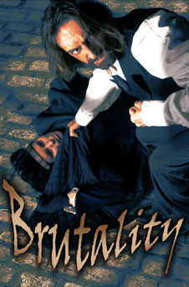Utterson and Enfield are out for a walk when they pass a strange-looking door (the entrance to Dr Jekyll’s laboratory). Enfield tells a story involving the door: in the early hours of one winter morning, he says, he saw a man trampling on a young girl. He pursued the man and brought him back to the scene of the crime. The reader later learns that this man is Mr Hyde.

A crowd gathered and, to avoid a scene, the man offered to pay the girl compensation. This was accepted, and he opened the door with a key, soon emerging with money and a large cheque.

Utterson is very interested in the case and asks whether Enfield is certain Hyde used a key to open the door. Enfield is sure he did.

|  |
| --- |
| **Chapter One: Consolidation - fill in the gaps!** |
| Mr Utterson is a dull but ‘loveable’ lawyer who people get help from when they are in __________ He is friends with a cousin, Enfield, and goes on regular walks with him on Sundays. One Sunday, they pass a dirty __________ in a poor area. Enfield tells Utterson a story about the door and the man who lives behind it. He says he saw a small, revolting man __________ a small __________ of eight at 3am in the morning. A crowd, led by Enfield, confronted the man and forced him to pay __________ in compensation. The man gave them a cheque which we learn at the very end of the chapter was signed by __________ __________ a very __________ person: no one believed that the cheque was __________ but later found out it was. Utterson is worried that Jekyll is being __________ by Mr Hyde. |
| **Comprehension: answer in full sentences on the next page.**   * What type of person is Mr Utterson?   *Mr Utterson is a lawyer who lives a quiet, serious life. He defends people who are down on their luck and is a good influence on them.*   * Why do Enfield and Utterson go for a walk together every Sunday? * What was of interest about the door that Enfield tells the story about? * What did the door look like? * Why and how did the crowd manage to get Hyde to write the girl’s family a cheque? What was odd about the cheque? * What is strange about Mr Hyde, according to Enfield? |

|  |  |  |  |  |
| --- | --- | --- | --- | --- |
| **Homework 5 Date of Test:** | **Read** | **Write** | **Cover and write** | **Definition** |
| **Pathway 1/2** | Verbs |  |  |  |
| Pronouns |  |  |  |
| Implies |  |  |  |
| Astonish |  |  |  |
| Creates |  |  |  |
| **Pathway 3/4** | Declarative |  |  |  |
| Simile |  |  |  |
| Articles (grammar) |  |  |  |
| Connectives |  |  |  |
| Bewilders |  |  |  |
| **Pathway 5/6** | Sibilance |  |  |  |
| Cacophony |  |  |  |
| Oxymoron |  |  |  |
| Deliberately |  |  |  |
| Signifies |  |  |  |
| **Pathway 7/8** | Ambiguity |  |  |  |
| Zoomorphism |  |  |  |
| Semantic Field |  |  |  |
| Indubitably |  |  |  |
| Insinuates |  |  |  |

**Homework 6**

**Chapter Two: Search for Mr Hyde**

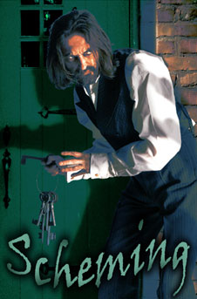That evening the lawyer, Utterson, is troubled by what he has heard. He takes the will of his friend Dr Jekyll from his safe. It contains a worrying instruction: in the event of Dr Jekyll's disappearance, all his possessions are to go to Mr Hyde.

Utterson decides to visit Dr Lanyon, an old friend of his and Dr Jekyll's. Lanyon has never heard of Hyde, and not seen Jekyll for ten years. That night Utterson has terrible nightmares.

Utterson starts watching the door (which belongs to Dr Jekyll's old laboratory) and eventually sees Hyde unlocking it. He is shocked by the sense of evil coming from him.

Utterson goes next door to warn his friend, Jekyll, against Hyde, but is told by the servant, Poole, that Jekyll is out and the servants have all been instructed by Jekyll to obey Hyde. Utterson is worried that Hyde may kill Jekyll to benefit from the will.

|  |
| --- |
| **Chapter Two: Consolidation - fill in the gaps!** |
| Mr Utterson, the lawyer, is troubled by the __________ that Henry Jekyll has written because it hands everything over to __________ if Jekyll dies or disappears for more than three months. Utterson visits Dr. Lanyon, a friend of Jekyll’s, to find out more, but discovers that Lanyon has __________ __________ with Jekyll over the ‘unscientific’ experiments Jekyll has been conducting. That night, Utterson suffers from nightmares. In one nightmare, he sees the figure of the man who trampled on the girl, and in another nightmare, the same figure approaches the sleeping Jekyll and makes Jekyll do what he wants. This figure has no __________ . On waking, Utterson is determined to find out what Hyde looks like so he spends his spare time standing by the door where Hyde lives. Eventually, one night, Hyde arrives and Utterson asks to look at his face: Hyde shows him it and then gives Utterson his __________ . Utterson realises that Hyde is thinking about the will and is frightened for Jekyll. When he goes to visit Jekyll, we realise something Utterson has known for a while – that the house that Hyde lives in is actually the laboratory attached to the back of Jekyll’s house. Utterson finds that Jekyll is out, and learns from the butler, Poole, that Hyde has a __________ to Jekyll’s laboratory and the servants have orders to __________ him. Utterson leaves feeling very worried that Hyde is blackmailing Jekyll. |
| **Comprehension: answer in full sentences on the next page.**   * Why is Utterson so upset about Jekyll’s will? * Why does Utterson visit Lanyon? Why has Lanyon lost interest in Jekyll as a scientist? * What is Utterson worried about and what does he dream about? * What steps does Utterson take to find Mr Hyde? * Why does Hyde accuse Utterson of lying to him? * Why does Utterson visit Jekyll immediately after seeing Hyde? * Why is Utterson even more worried about Jekyll at the end of the chapter? |

**Homework 7**

**Jekyll and Hyde: The Influence of Darwin**

Gothic literature focuses on ruin, decay, death, madness, terror and chaos. It often shows people of privilege behaving irrationally and passionately, ignoring common-sense and reason. This sense of horror grew in response to the fears and concerns of people in the late eighteenth and early nineteenth centuries. At the time, scientific discovery was upsetting what some people believed, and this fear of the new and unfamiliar led to books like Frankenstein being written. in it, a scientist uses his knowledge to accidentally create a monster – a fear which people still have today when it comes to new scientific discoveries (just think about the fuss over cloning or genetically modified foods).

[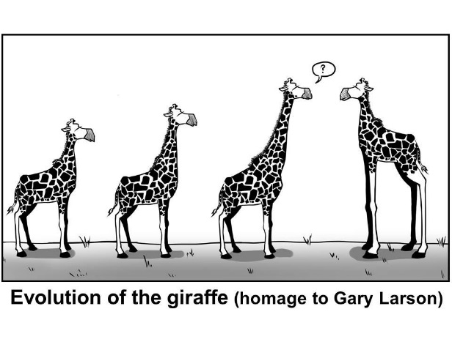](http://www.google.co.uk/url?sa=i&rct=j&q=&esrc=s&source=images&cd=&cad=rja&uact=8&ved=0ahUKEwjnxu3m687KAhUKWBQKHcJWCy0QjRwIBw&url=http://www.evolution-outreach.com/content/6/1/11/figure/F5?highres=y&bvm=bv.113034660,d.d24&psig=AFQjCNF6NnHHnvKm1jdHUKSGTUeXnfarjg&ust=1454150720884576)People’s beliefs were also challenged by Charles Darwin’s theory of evolution. This showed that different species had evolved through a process called ‘natural selection’, in which animals pass on their strongest characteristics, meaning their offspring are better suited to the environment they live in. In this way, species become stronger and stronger. See the diagram to show how giraffe evolved…

This theory was deeply disturbing for many people, as it challenged their religious beliefs: Darwin’s theory completely goes against the Bible’s teachings, in which God created Adam and Eve. Many people felt they were being forced to choose between their long-held religious beliefs and science – and many believed that science was meddling in matters that only God had control over.

Rather than being innocent creatures created by a powerful god, this theory meant that we had evolved from more primitive creatures by accident – something many people found appalling because it showed we were more closely related to the animal kingdom than people had assumed. The theory was also misunderstood by many who believed that this meant we were evolved from monkeys and apes – which we are not.

**How did Darwin’s theory influence Jekyll and Hyde? ________________________________________________________________________________________________________________________________________________________________________________________________________________________________________________________________________________________________________________________________________________________________________________________________**

**NB Hyde’s Physical Appearance**

Hyde appears repulsively ugly and deformed, small, shrunken, and hairy. His physical ugliness and deformity symbolises his moral hideousness and warped ethics. Indeed, for the audience of Stevenson’s time, this connection might have been seen as more than symbolic. Many people believed in the science of physiognomy, which said that one could identify a criminal by physical appearance. Additionally, Hyde’s small stature may represent the fact that, as Jekyll’s dark side, he has been repressed for years, prevented from growing and flourishing. His hairiness may indicate that he is not so much an evil side of Jekyll as the embodiment of Jekyll’s animal instincts.

**Homework 8**

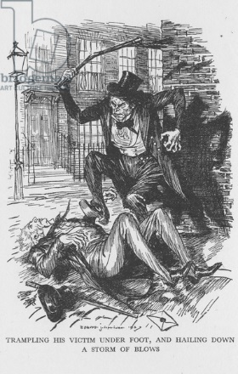**Violence Against Innocents**

The text repeatedly depicts Hyde as a creature of great evil and countless vices. Although the reader learns the details of only two of Hyde’s crimes, the nature of both underlines his depravity. Both involve violence directed against innocents. In the first instance, the victim of Hyde’s violence is a small, female child whom he tramples; in the second instance, it is a gentle and much-beloved old man.

The fact that Hyde injures a girl and ruthlessly murders a man, neither of which has done anything to provoke his rage or to deserve death, emphasises the extreme immorality of Jekyll’s dark side. Hyde’s brand of evil is not just a lapse from good behaviour but an outright attack on it.

**Glossary -** *Write a definition of these words.*

Vices:

Depravity:

Immorality:

Lapse:

**Write your own paragraph, explaining why Hyde’s attacks are so shocking. You must include the following words: abhorrent, brutal, depraved, feral, immoral, savage.  
________________________________________________________________________________________________________________________________________________________________________________________________________________________________________________________________________________________________________________________________________________________________________________________________________________________________________________________________________________________________________________________________________________________________________________________________________________________________________________________________________________________________________________________________________________________________________________________________________________________________________________________________**